МИНИСТЕРСТВО ОБРАЗОВАНИЯ И НАУКИ РОССИЙСКОЙ ФЕДЕРАЦИИ
Государственное образовательное учреждение
высшего профессионального образования
«Пермский государственный педагогический университет»
Кафедра иностранных языков

АНГЛИЙСКИЙ ЯЗЫК
ДЛЯ ДЕЛОВОГО ОБЩЕНИЯ

Учебно-методическое пособие
для студентов дневного и заочного отделений неязыковых факультетов

Часть I

Пермь
ПГПУ
2011
УДК 802.0
ББК Ш 143.21
А 647

Р е ц е н з е н т :
старший преподаватель кафедры иностранных языков, лингвистики и межкультурной коммуникации Пермского государственного
технического университета М.А. Киловатая

Авторы-составители: ст. преп. каф. иностранных языков Н.П. Зонина,
ст. преп. каф. иностранных языков И.Ю. Субботина

А 647 | Английский язык для делового общения : учеб.-метод. пособие для студентов дневного и заочного отделений неязыковых факультетов. Ч. 1 / авт.-сост. Н.П. Зонина, И.Ю. Субботина ; Перм. гос. пед. ун-т. – Пермь, 2011. – 71 с.

Пособие охватывает три темы делового общения – первое знакомство, деловая корреспонденция и презентация компании. Кроме упражнений, направленных на формирование речевых умений и навыков, в пособие включены фонетические и грамматические упражнения, а также англо-русский словарь. В конце пособия имеются тексты аудиозаписей и тесты на проверку изученного материала.
Предназначено для студентов заочного отделения факультета Информатики и Экономики и для студентов дневного отделения неязыковых факультетов ПГПУ.
УДК 802.0
ББК Ш 143.21

Печатается по решению учебно-методического совета
Пермского государственного педагогического университета

© Зонина Н.П., Субботина И.Ю., составление, 2011
© ГОУ ВПО «Пермский государственный
педагогический университет», 2011

ОГЛАВЛЕНИЕ

Unit 1. Meeting People …………………………………………………..4

Unit 1. Workbook ……………………………………………………….14

Unit 2. Telephoning …………………………………………………….20

Unit 2. Workbook ………………………………………………………38

Unit 3. Companies ……………………………………………………...45

Unit 3. Workbook ………………………………………………………55

Tapescripts ……………………………………………………………...61

Test I ……………………………………………………………………66

Список литературы …………………………………………………….70

UNIT 1
MEETING PEOPLE
Objective: to meet foreign contacts and get to know them.
Tasks: to introduce yourself to other people, to describe jobs and responsibilities, to find out about other people’s jobs, to ask questions about foreign companies, to read and write a personal profile.

I. P r e s e n t a t i o n

1. Do you know the other people in the class? Introduce yourself to everyone.
Good morning / Good afternoon / Good evening.
My name is ... and I work for…/ I work in…/ I study at … .

2. Look at the people in the photographs.
1) Is it a formal or informal situation? 2) What are they saying?

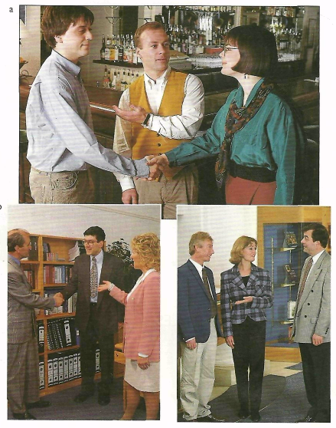
Learn the following words and word combinations.

to introduce – представить
conversation – разговор, беседа
to complete – заканчивать
How do you do? – Здравствуйте.
branch – ветвь, отрасль, филиал
to be responsible for – быть ответственным за
account – счет
right order – правильный порядок
to check – проверять
Welcome to – Добро пожаловать
colleague – коллега
Let’s go. – Пойдем.
upstairs – наверх
Pleased to meet you. – Рад познакомиться.
What about you? – А вы?
construction – строительство
reception desk – стол администр-ра
appointment – условленная встреча

3. Tape 1. Listen to three conversations and match each one to the correct picture.
4. Tape 1a. Listen to the first conversation again and complete this conversation.
Louise: Mr Velazquez, ___ ___ ___ you to Peter Brien.
Peter, ___ ___ Mr Velazquez of Telefonica de Espana.
Mr Velazquez: ___ ___ ___ ___?
Peter: ___ ___ ___ ___?
Louise: Peter works for our New York branch.
He’s ___ ___ international accounts.

5. Tape 1b. Put this conversation in the right order. Then listen to the second conversation again and check your answers.
a) Thomas: Yes, I do. How are you, Sven?
b) Sven: Not bad, thanks.
c) Thomas: Welcome to Oxford. It’s nice to see you again.
d) Thomas: Good. Let’s go upstairs and have some coffee.
e) Sven: Fine thanks, Thomas. And you?
f) Ulla: And you. Do you know my colleague, Sven Olsen?
g) Thomas: Fine. How was your trip?

6. Tape 1c. Listen to the third conversation again and correct the mistakes in these sentences.
1) Bob, Liz and Luigi are in an office.
2) It’s the afternoon.
3) Liz and Luigi work together.
4) Luigi is in the construction business.

7. Work in groups. Practise making introductions. Introduce:
1) two people in a formal situation.
2) two people in an informal situation.
3) yourself at a company reception desk.
4) yourself to a new colleague.
5) yourself to a foreign visitor you are meeting at an airport.

Use the following phrases:

May I introduce you to ... ? ... this is ...
How do you do? How do you do?
Do you know ... ? ... this is ...
Hello. / Hi. Nice to meet you.
Good morning. My name is ... I have an appointment to see ...
I don’t think we’ve met, I’m ...
Excuse me. Are you …? I’m ...
II. L a n g u a g e w o r k
G e t t i n g i n f o r m a t i o n

Learn the following words and word combinations.

1. business card – визит. карточка
deputy – заместитель
managing director – управляющий
public relations – связи с общественностью
officer – представитель, служащий
headquarter – главное управление
sales representative – торговый представитель
3. space – отведенное место
to find out – узнавать
data – данные
communication system – сист. связи
to attend – присутствовать
member – член
division – отдел, подразделение
lounge – холл
4. single – одинок, холост
be married – быть женатым
to produce – производить
to sell – продавать
department – отдел
5. job – работа
responsibility – ответственность

1. Five people are visiting your company today. Look at their business cards and ask and answer questions about them.

What’s his/her name? (What is) What nationality is he/she?
Who does he/she work for? Where does he/she work?
What’s his/her position in the company?

S C A N E S BA N K E N
Birgitte Svensson
Deputy Managing Director
Nybrokajen 7
S – 15146 Stockholm
Tel: 08 663 50 40
Fax: 08 665 40 55
CHEMA Y PUNTO SA
Margarita Vidal Romero
Public Relations Officer
Paseo de la Castellana 201
Madrid
Tel: 1 431 2687
Fax: 1 435 1314
B S C S
Business Systems Consultancy Services
Dale Crosby
Vice President
1049 Derwent Drive
Santa Barbara California
Tel:805 963 9171 Fax:805 962 8593
NIHON INFORMALINK KK
Noburo Yaegashi
Sales Representative
Headquarters Informalink BLDG
248 Kanamecho
Toshima-ku Tokio 171
Tel: 5995 3801 Fax: 5995 3919
DEUXMONT FRANCE
Jean-Claude Aurelle
Technical Director
132 rue Veron,
94140 Alfortville, France
Tel: 143 762 281 Fax: 143 762 924
2. Now find out about the people sitting next to you.
What's your name? What nationality ... ? etc.

3. Put the right question word in the spaces.
When Where Why What How Who Which

Welcome to the Conference
1) ___ are you here? To find out about IPQ’s newest product.
2) ___ is it? The RM110 data communication system.
3) ___ many people are attending? 76.
4) ___ are they? European members of the IPQ team.
5) ___ divisions do they work in? Marketing and Sales.
6) ___ do we meet? At 6 o’clock this evening.
7) ___ do we meet? In the Regency Lounge (1st floor).

4. Here are some answers, but what are the questions?
- How do you do?
- Jose Perez.
- English, Spanish, and Italian.
- I’m Spanish.
- No, I'm single.
- IBM.
- They produce and sell computers.
- The financial department.
- I’m an auditor.

5. Write some questions to ask a colleague. Use the Present Simple tense. Ask your group mates about: their company, their job, their responsibilities, their hobbies and interests, their study.

D e s c r i b i n g j o b s

Learn the following words and word combinations.

1. in bold type – жирным шрифтом
controller – инспектор
employer – работодатель
to do for a living – зарабатывать
на жизнь
so – итак, таким образом
product manager – менеджер
по производству
3. executive manager – исполнительный директор
chief – генеральный, главный
CIO – chief executive officer – руководитель фирмы, глава компании
research – исследование
development – развитие
production – производство
to be in charge of – отвечать за
to be responsible to – отчитываться
to report to – отвечать перед

1. Study the words in bold type in these sentences.
I’m a financial controller. I’m an engineer. (a/an + job)
I work for ATT. (for + employer)
I’m in marketing. I’m in the chemicals business.
I’m in chemicals. (in + type of work)

2. Complete this conversation. Use a, an, for, and in.
A: What do you do for a living?
В: I’m ___ computers.
A: Really? Who do you work ___ ?
В: Olivetti. I’m ___ product manager. What about you?
A: I work ___ Balfour Beatty.
В: So you’re ___ the construction business?
A: Yes. I’m ___ engineer.

3. Complete these sentences about yourself.
1) I’m a/an ___.
2) I work for ___.
3) I’m in ___.

4. How many executive managers and divisions does this organization have?
Mr Richard Baldwin, President and Chief Executive Officer

Dr Kevin Higgins, Research and Development Division

Mr David Ellingham, Production Division

Mrs Petra Cusimano, Finance, Personnel and Administration Division

Ms June Hesketh, Marketing and Sales Division

5. Ask and answer questions about it.
Who is responsible for / Who is in charge of production? Mr Ellingham.
Who is he responsible to? / Who does he report to? The Chief Executive Officer.

6. Find out about your partner.
Which division do they work in?
What are they responsible for? / What are they in charge of?
Who are they responsible to? / Who do they report to?

C o m m u t e r s

Learn the following words and word combinations.

commuter – едущий на работу,
пассажир
journey – путешествие, поездка
roller blades – роликовые коньки
ahead – впереди
jeweller – ювелир
on bike – на велосипеде
has to – должен
traffic – дорожное движение
by train – на поезде
to travel – ехать, путешествовать
to leave – покидать, уезжать

1. Read stories about these commuters.

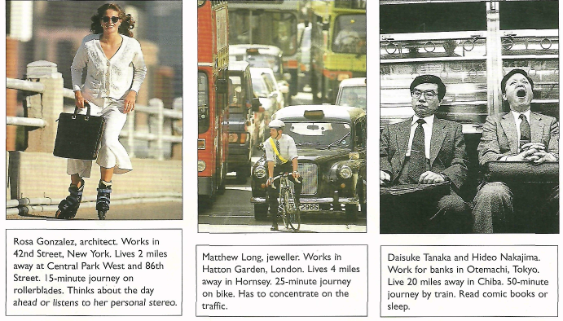

A B C

A) Rosa Gonzalez, architect. Works in 42nd Street, New York. Lives 2 miles away at Central Park West and 86th Street. 15-minute journey on rollerblades. Thinks about the day ahead or listens to her personal stereo.
B) Matthew Long, jeweller. Works in Hatton Garden, London. Lives 4 miles away in Hornsey. 25-minute journey on bike. Has to concentrate on the traffic.
C) Daisuke Tanaka and Hideo Nakajima. Work for banks in Otemachi, Tokyo. Live 20 miles away in Chiba. 50-minute journey by train. Read comic books or sleep.

2. Ask and answer questions about these commuters.
e.g. What does Rosa do for a living?
Where does she live? Where does she work?
Ноw long does it take to get there? How far is it?
How does she get there? What does she do on the journey?

3. Now ask a partner similar questions about his/her journey to work.

C o u n t r i e s a n d N a t i o n a l i t i e s
1. Complete the chart.

Country Nationality
Japan……………Japanese
The USA………..___
___.......................Italian
Sweden………….___
___.......................Norwegian
Denmark………..___
___......................Russian
Canada………….___
Country Nationality
France………….___
___.....................British
Switzerland…….___
Germany……….___
The Netherlands..___
___......................Brazilian
Spain……………___
___......................Chinese

2. Toshiba is a Japanese company. The headquarters are in Japan.
What about these companies? Honda, IBM, Olivetti, Ericsson, L’Oreal, Rolls Royce, Nestle, Siemens, Philips.

P e r s o n a l i t y p r o f i l e

Learn the following words and word combinations.

called – по имени
to miss – пропускать
to suggest – предполагать
possible – возможный
He comes from – он уроженец
years of age – лет
successful – успешный
chairman – председатель
property – собственность
shipbuilding – кораблестроение
distribution – распространение
band – муз. группа
including – включая
unusual – необычный
inside – внутри
to hate – ненавидеть
balance sheet – баланс
profit – доход
loss – потеря, расход
to wear ties– носить галстуки

1. Read this article about a businessman called George Wong. What information is missing? Suggest possible words to fill the spaces.

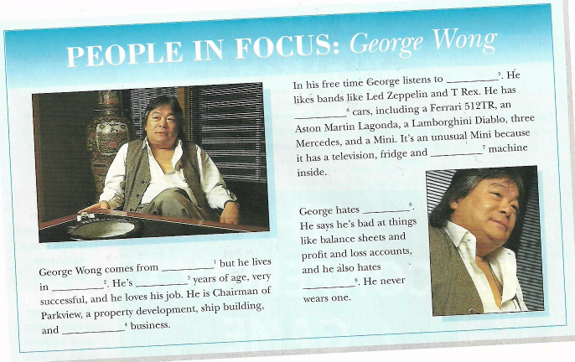

George Wong comes from ________ (1) but he lives in _______ (2). He’s _______ (3) years of age, very successful, and he loves his job. He is Chairman of Parkview, a property development, ship building, and ________ (4) business.
In his free time George listens to ________ (5). He likes bands like Led Zeppelin and T Rex. He has _________ (6) cars, including a Ferrari 512TR, an Aston Martin Lagonda, a Lamborghini Diablo, three Mercedes, and a Mini. It’s an unusual Mini because it has a television, fridge and ________ (7) machine
inside.
George hates ________ (8). He says he’s bad at things like balance sheets and profit and loss accounts, and he also hates ________ (9). He never wears one.

2. Work with a partner. One person asks his/her partner questions to get the information missing from the article. The other uses the information below and answers the questions.
e.g. Where does George Wong come from? Where does he live?

The missing information:
nationality – Taiwanese, home town – Hong Kong, age – 42, company – Parkview (a property development, ship building and car distribution business), hobby – listens to rock music, things he loves – his cars (he has 10 including three Mercedes and a mini with a television, fridge and Karaoke machine inside), things he hates – numbers and ties.

P r o n u n c i a t i o n

Learn the following words and word combinations.

to mark – отметить
syllable – слог
main – главный
stress – ударение
to fall – падать
sure – уверенный

1. Tape 2. Listen to these words from Unit 1. Mark the syllable where the main stress falls. E.g. international

a) construction
b) engineer
с) headquarters
d) financial
e) European
f) responsible
g) responsibilities
h) nationality

2. Now practise saying the words. Make sure you stress the right syllable.

III. S k i l l s w o r k

Learn the following words and word combinations.

participant – участник
toss a coin – подбросить монетку
heads – передняя сторона монеты
to move – передвигать
square – квадрат
tails – обратная сторона монеты
to follow – следовать
winner – победитель
to arrive – прибывать
to register – зарегистрироваться
job – работа (по специальности)
to ask – спрашивать
to name – назвать
on holiday – в отпуске
to greet – приветствовать
to bow – поклониться
to exchange – обменяться
different – различный

Speaking ex.1. Work in twos or threes. You are participants at an international conference. Toss a coin to move.
- Heads: move one square.
- Tails: move two squares.
Follow the instructions on each square and start a conversation. The first person to finish is the winner.

START
1) You arrive at the conference hotel. Go to the reception desk and register.
2) Introduce yourself to another person at the conference.
3) Ask another person at the conference what their job is.
4) Name four countries you want to visit on holiday.
5) Ask another person about their company.
6) You see an old friend. Greet him/her.
7) Name three countries which begin with the letter “B”.
8) Ask another person where they come from.
9) Introduce two people to one another.
10) Ask another person about their family.
11) Name two countries where you bow when you meet someone.
12) Ask another person about their hobbies and interests.
13) Exchange business cards with another participant.
14) Say “thank you” in three different languages.
15) Ask another person about the department or division they work in.
16) It’s time to go home. Say goodbye to your new friends.
FINISH
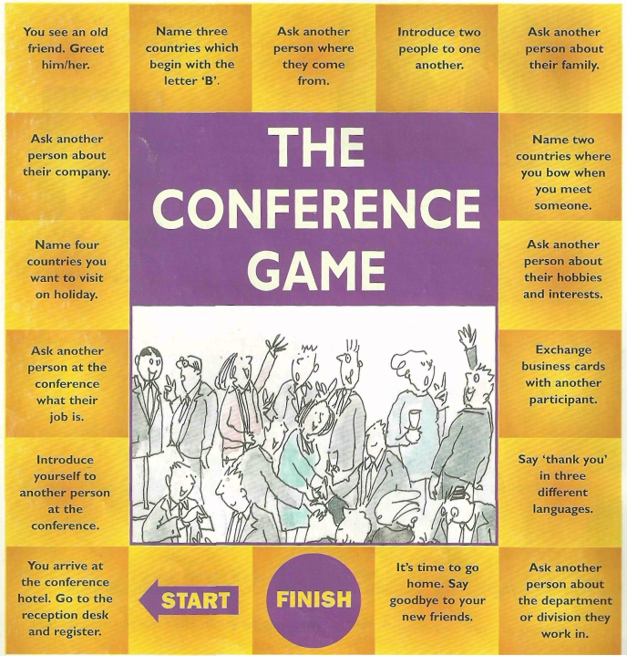

W r i t i n g

Learn the following words and word combinations.

profile – краткий биографический очерк
below – ниже
topic – тема обсуждения
home town – родной город
responsibilities – должностные обязанности
lovely – чудесный
village – деревня
private – частный
activity – деятельность
to divide – делить
area – сфера, зона
shipping – перевозка груза
property – недвижимость
trading – торговля
best-known – самый известный
airways – авиалинии
head – глава
busy – занятый
fishing – рыболовство
to grow – выращивать
own – собственный
vegetables – овощи
just for fun – просто для удовольствия

Read the profile of Derek Stirling and then write another profile about yourself. Use the topics below to help you: name, nationality, home town, company, position in the company, responsibilities, hobbies.

Profile
My name is Derek Stirling and I’m Scottish. I live in Hadlow, a lovely English village near London, and I work for The Swire Group, Britain’s largest private company. The Group’s activities are divided into five business areas: shipping, aviation, property, industries, trading. Our best-known company is Cathay Pacific Airways.
I work at our London head office; I’m head of Corporate Finance, and I’m responsible for developing the business of the Group.
I’m always very busy and I don’t have much free time, but when I
do, I like fishing and I grow my own vegetables, just for fun.

Learn the following words and word combinations.

interview – опрашивать
to learn – учиться
objective – цель
to communicate with – общаться c
most – больше всего
to spend – проводить
equipment – оснащение
to buy – купить
dictionary – словарь
satellite dish – спутниковая тарелка
video recorder – видеомагнитофон
stationary items – канцелярские принадлежности
personal stereo – плеер

Speaking ex. 2. Interview a partner about their learning objectives.
1) Why do they want to learn English?
2) Who do they want to communicate with in English?
3) What do they want to practise most: reading, writing, listening, or speaking?
4) How many hours a week can they spend studying English?
5) What equipment and materials do they have to help them learn?

UNIT 1
WORKBOOK

Learn the following words and word combinations.

Excuse me, … – Извините, …
to call – называть
May I …? – Можно я …?
over there – вон там

1. First meetings. Put this conversation into the correct order. (1-d)
a) Elaine: Please call me Elaine.
b) Paul: Morning, Jenny. How are you?
c) Jenny: Yes, it is. Let me introduce you ... Excuse me, Mrs Redford.
May I introduce you to Paul Carroll?
d) Jenny: Good morning, Paul.
e) Paul: Pleased to meet you, Mrs Redford.
f) Jenny: Fine, thanks, and you?
g) Paul: And please call me Paul.
h) Elaine: How do you do?
i) Paul: Fine. Is that Mrs Redford over there?
Learn the following words and word combinations.

estate agent – агент по недвижимости
accountant – бухгалтер
solicitor – адвокат, юрисконсульт
to buy – покупать
to sell – продавать
to work for – работать на
to work at – работать в (место)
to work in – работать в (отдел)
to work on – работать над
other – другой
corporate law – корпоративное право
to produce – производить
equipment – оборудование
toy – игрушка
manufacturer – производитель
service – услуга
section – отдел
to build – строить
project – проект
Middle East – Ближний Восток

2. Jobs. Complete the sentences using the following phrases:
for Lego in computers a doctor an accountant
for Canon an estate agent in construction a solicitor

1) I’m _________. I buy and sell houses.
2) I’m __________. I work for IBM.
3) I’m _________. I specialize in corporate law.
4) I work _________. We produce photocopiers, fax machines, and
other office equipment.
5) I’m _________. I work at Guy’s Hospital in London.
6) I work _________, the Danish toy manufacturer.
7) I’m _________. I work in the financial services section.
8) I’m _________. I work on building projects in the Middle East.

Learn the following words and word combinations.

title – название
human resources – отдел кадров
to describe – описывать
briefly – кратко
at work – на работе
personnel – персонал
matter –дело
to recruit – набирать
staff – штат, персонал
to liaise – поддерживать связь
health – здоровье
safety – безопасность
representative – представитель
training course – обучающие курсы
to deal with – иметь дело с
retirement –выход на пенсию
arrangement – договор, организация

3. Job titles. a) Think of three people you work with, write their names and job titles.
Name Job title
e.g. Nadine Calvo Human Resources Director
1) ___________ ___________________
2) ___________ ___________________
3) ___________ ___________________
b) Describe briefly what one of the people does at work.
e.g. Mme Calvo is our Human Resources Director. She is responsible for all personnel matters. She recruits new staff, liaises with health and safety representatives, organizes training courses, and also deals with retirement arrangements.

c) Now describe your job. Say what you do at work.

Learn the following words and word combinations.

to match – подбирать, соответствовать
main – главный
activity – область деятельности
to base – размещаться
currency – валюта
rubber – каучук, резина
forestry – лесные массивы
shipbuilding – кораблестроение
beverage – напиток

4. Companies. Match these companies to their main business activities, the countries in which they are based, and the countries’ currencies.

Use the information below:
South Korea, Japan, Finland, Italy, Switzerland, France, USA, Denmark
rubber products, forestry products, shipbuilding, food, photographic equipment, electronics, beverages, computers
krone, franc, lira, dollar, yen, markka, won, Swiss franc.

Company Main business activity Country Currency
Olivetti computers Italy lira
Mitsui _________ _____ ______
Jacobs Suchard __________ _____ ______
Eastman Kodak _________ _____ ______
Daewoo electronics ______ ______
Michelin __________ ______ _______
Rauma-Repola __________ ______ _______
Carlsberg __________ ______ _______

Learn the following words and word combinations.

lawyer – юрист
to fill in – заполнять
blank – пробел, пропуск
question – вопрос
to give a talk – читать доклад
satellite – спутник
launch – запуск
transmission – передача
I’d like to … – я бы хотел …
What don’t you …? – Почему бы вам не …?
to come along – пойти
What time …? – Во сколько …?
to complete – заканчивать
some – несколько
actually – фактически, на самом деле, действительно
was born in – родился в

5. Asking questions. a) Read this conversation between two lawyers at a conference. Fill in the blanks with these question words:
who what how why when where
Klaus: _________(1) do you do? I’m Klaus Binder.
Peter: Nice to meet you. Peter Green.
Klaus: Ah! You’re giving a talk on satellite launches.
Peter: That’s right. _________(2) are you from, Mr Binder?
Klaus: Berlin.
Peter: And _________(3) do you work for?
Klaus: Sky Television.
Peter: Ah, yes! You’re giving a talk on transmission systems.
Klaus: That’s right.
Peter: I’d like to hear it. _________(4) is it?
Klaus: After lunch. _________(5) don’t you come along?
Peter: I’d like to. _________(6) time does it start?

b) Ask Peter some questions about Klaus. Complete the conversation.
You: Who is that man over there?
Peter: His name is Klaus Binder.
You: _____________________(1)?
Peter: Berlin.
You: _____________________(2)?
Peter: No, he’s Austrian, actually, but he was born in Germany.
You: _____________________(3)?
Peter: Sky Television.
You: _____________________(4)?
Peter: He’s an engineer.
You: _____________________(5)?
Peter: He’s the Technical Director.

Learn the following words and word combinations.

boardroom – зал заседаний совета директоров
puzzle – головоломка
to work out – разработать, составить, решить
everyone – каждый
at the head of – во главе
different – разный
MD (Managing Director) – управляющий
right-hand side – правая сторона
opposite – напротив

6. Boardroom puzzle. Three business people are at a meeting. From the information below, work out everyone’s name, nationality, job, and where they are sitting.
- The Managing Director is at the head of the table.
- The people come from three different countries.
- They have three different jobs. There’s the MD, an accountant, and a lawyer.
- The Accountant comes from Switzerland.
- The Englishman is on the MD's right-hand side.
- Peter comes from Germany
- The Lawyer’s name is Nathan.
- Bernadette is opposite the man from England.

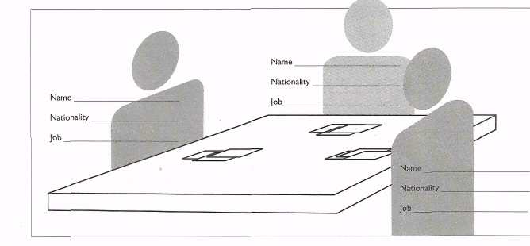

Learn the following words and word combinations.

passage – отрывок
to miss – пропускать
hundred – сотня
to leave – уходить из
it takes – это занимает
to enjoy – наслаждаться
to get bored – скучать
trivial – пустой, обыденный, незначительный, банальный
pursuit – погоня, стремление, поиск, занятие
to use – использовать
two and a half hours – два с половиной часа

7. Commuting. a) Read this passage about a commuter. Think about what information is missing.
Annie Clayden lives in Norwich but she works in ________(1) , a hundred miles away: She leaves home at __________(2) in the morning and she travels to work by _________(3). It takes _________(4) but she enjoys the journey. She travels with __________(5) and she doesn’t get bored because ___________(6).
b) What questions can you ask to get the missing information?
1) Where _______________________________________________________?
2) What time ____________________________________________________?
3) How_________________________________________________________?
4) How long _____________________________________________________?
5) Who_________________________________________________________?
6) Why_________________________________________________________?

c) Here is the missing information. Now use it to complete the passage.
two and a half hours London three friends
they all play Trivial Pursuit 6-30 train

8. Replies. Match these questions to the correct reply.
1) Where do you come from? a) About half an hour.
2) How do you do? b) Spain.
3) How are you? с) I’m Swiss.
4) How long does it take? d) Cathay Pacific.
5) Who do you work for? e) No, I’m from Canada.
6) What line of business are you in? f) I’m an accountant.
7) What nationality are you? g) Advertising.
8) How do you get to work? h) How do you do?
9) Are you American? i) By train.
10) What do you do? j) Fine, thanks and you?

Learn the following words and word combinations.

advertising – реклама
rule – правило
like – подобно
example – пример
to test – испытывать, проверять
to arrive – прибыть
late – поздно
to collect – собирать
shut – закрытый
to forget – забывать
to invest – вкладывать деньги
unavoidably – неизбежно
to delay – задерживать
employee – работник
to remind – напоминать
any more – какие-нибудь еще

9. Reading. a) Match the sentences below to make rules like the one in the example.
e.g. Managers don’t make mistakes. They test their staff.
1) Managers don’t arrive late. a) They collect information.
2) Managers don’t read the newspaper. b) They think with their eyes shut.
3) Managers don’t forget things. с) They invest in new technology.
4) Managers don’t sleep. d) They are unavoidably delayed.
5) Managers don’t buy new toys. e) If they do, they’re the managers’ ideas.
6) Employees don’t have good ideas. f) Their employees forget to remind them.

b) Can you make any more rules?
UNIT 2
TELEPHONING

Objective: to make contact and exchange information over the phone telephone calls.
Tasks: to spell and note down key words and numbers in a telephone message; to make, agree to, and refuse requests; to respond to new situations and say what action you will take; to write business letters.

I. P r e s e n t a t i o n

Learn the following words and word combinations.

1. supply – поставка, запас
overseas – заграничный
to be busy – быть занятым
to hold – подождать
to be free – быть свободным
to put through – соединить
firesafe – пожаростойкий
cabinet – шкаф
to arrange for – устраивать
necessary – необходимый
to quote – дать расценку, цитировать
price – цена
code – код (города)
to read back – зачитать
to work out – составлять
quotation – цена, расценка
immediately – немедленно
extension – добавочный номер
Who’s calling? – Кто говорит?
to place – разместить
order – заказ
certainly – конечно
Go ahead – Продолжайте
photoconductor – фотопроводники
unit – элемент, агрегат
reference – справочный
stroke – ход
in stock – в наличии
Anything else? – Что-нибудь еще?
That’s all. – Это все.
urgent – срочный
to send – посылать
straight away – сразу
to confirm – подтвердить
of course – конечно
2. switchboard – коммутатор
to connect – соединять
caller – звонящий
3. similar – подобный
meaning – значение
I’m ready. – Я готов.
to be engaged – быть занятым
area – район, область, зона
Is that all? – Это все?
to wait – ждать

1. Study these forms. What are they for?

Tape 3. Listen to the two telephone conversations and complete the forms.

Conversation 1

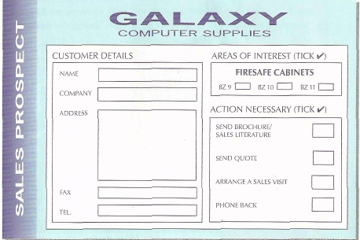

Conversation 2

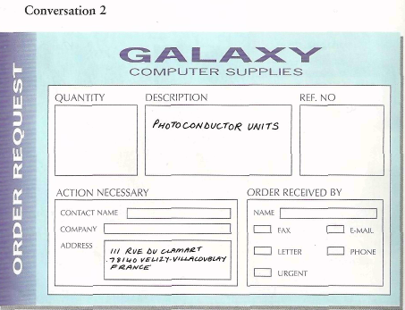

2. Listen to the conversations again and answer these questions.

Tape 3a. a) Why doesn’t the switchboard operator connect the caller
immediately? b) What does the woman say she’ll do?

Tape 3b. с) What question does Christophe Terrien ask about the
photoconductor units? d) What does Mary Thatcher ask Monsieur Terrien to do?

3. Match the words and phrases (1-10) with similar meanings (a-j).

1) The line’s busy.
2) Will you hold?
3) I’ll put you through.
4) A code.
5) An extension number.
6) Who’s calling please?
7) Hold on.
8) This is …
9) Go ahead.
10) Anything else?
a) I’ll connect you.
b) One moment.
c) An office number.
d) Could I have your name?
e) I’m ready.
f) The line’s engaged.
g) A country or area number.
h) Is that all?
i) Can you wait?
j) … speaking.

II. L a n g u a g e w o r k
S t a r t i n g c a l l s

Learn the following words and word combinations.

to study – изучать
phrase – фраза
call – звонок
to identify – опознать
to want – хотеть
to supply – восполнить
sales – продажа, сбыт
department – отдел
to get smb – позвать кого-либо
accounts – счет, бухгалтерия
to help – помогать
to listen – слушать
to check – проверять
answer – ответ

Study these phrases for starting calls.

Identifying who is speaking:
This is Paul Henig.
Paul Henig speaking.
Is that Julia Gardini?

Saying who you want to speak to:
Could I speak to ... ?
Can I speak to ... ?
I’d like to speak to ...
Extension 596, please.

Supply the missing words in these conversations.
1) Ms Brunet: Sales Department, good morning.
Mr Keller: _________Helena Steiner, please?
Ms Brunet: Hold on. I’ll get her.

2) Mrs Steiner: Hello, Sales.
Mr Keller: ______________ Helena Steiner, please.
Mrs Steiner: ______________.

3) Switchboard: Curtis Holdings.
Mr Keller: ________ 293, please.
Miss Delmont: Accounts Department.
Mr Keller: _________ Jean Delmont?
Miss Delmont: Yes, _____. How can I help you, Mr Keller?

Tape 4. Listen to check your answers.

P r o n u n c i a t i o n

Learn the following words and word combinations.

1. chart – таблица, схема
sound – звук
together – вместе
to pronounce – произносить
2. to try – пытаться
on your own – сами
3. to hear – слушать
spelt – произнесенный
exhibition – выставка
dot – точка
above – вверху
to be sure – быть уверенным
4. in turns – по очереди
glossary – словарь

1. Tape 5a. Can you spell English words over the phone? Listen to the
English alphabet and look at the chart. All the letters with similar sounds are grouped together.

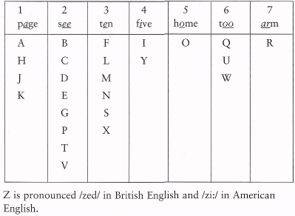

2. Study the chart for a moment then close your book and try writing it on your own.

3. Tape 5b. Listen, and write down the words you hear spelt.

1) ___________________
2) ___________________
3) ___________________
4) ___________________
5) ___________________

4. Work with a partner. Take it in turns to dictate abbreviations and write them down. One person dictates the abbreviations from the first column, and the other dictates the ones from the second column.

IBM FOB OPEC
EU CIF GB
JAL AGM FBI
VAT USA IT
CEO GDP VIP
WHO IMF CIA

Do you know what these letters stand for?

IBM – International Business Machines
FOB – Free on Board (export price which includes the cost of shipping)
OPEC – Organization of Petroleum Exporting Countries
VIP – Very Important Person
EU – European Union
CIF – an export price including Cost, Insurance and Freight
JAL – Japan Airlines
AGM – Annual General Meeting
FBI – Federal Bureau of Investigation
IT – Information Technology
VAT – Value Added Tax
USA – United States of America
CEO – Chief Executive Officer
GDP – Gross Domestic Product
WHO – World Health Organization
GB – Great Britain
IMF – International Monetary Fund
CIA – the Central Intelligence Agency

T r a n s f e r r i n g i n f o r m a t i o n

Learn the following words and word combinations.

1. to notice – обратить внимание
to exchange – обмениваться
2. common – общепринятый
elsewhere – где-нибудь
в другом месте
3. to transfer – передавать
to leave – оставлять
silence – молчание
Got that. – Понял.
message – сообщение

1. Notice these different ways of saying telephone and fax numbers.
91430 – nine one four three zero (American English)
– nine one four three oh (British English)
6687 – six six eight seven (American English)
– double six eight seven (British English)
Exchange your work and home telephone numbers with a partner.

2. Work with a partner. Take it in turns to dictate telephone numbers and write them down. One person dictates the telephone numbers from the first line, and the other dictates the ones from the second line.
29508 47766 966015 01525 372245 03 916 600721
34067 88159 270664 01799 241536 0171 863 7760

Pronunciation note
In phone and fax numbers, English speakers normally group the numbers in threes, not in twos as is common elsewhere in Europe.
914306 — nine one four, three oh six; not nine one, four-three, oh six.

3. When you transfer information by phone, try not to leave long silences or pauses. These phrases will help you.
Starting: Ready? Go ahead.
Continuing: Have you got that? Got that.
Finishing: Anything else? That’s all.
Checking: Could you read that back to me? Could I read that back to you?

Work with a partner. Take it in turns to give each other messages and write them down. Dictate the messages below to each other.
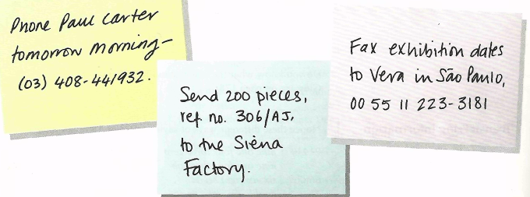
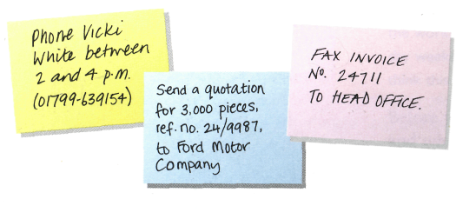

D e c i d i n g w h a t t o d o

Learn the following words and word combinations.

1. have to – должен
to decide – решать
to delay – задерживаться
need – нуждаться
to order – заказывать
to hire – нанимать
to give a lift – подвезти
confirmation – подтверждение
to send – посылать
to faint – упасть в обморок
glass – стакан
2. available – доступный
reason – причина
sick – больной
to be tied up – быть связанным
just now – прямо сейчас
3. to ring – звонить
to take a message – принять сообщение
to give a message – передать сообщение

1. Sometimes we meet new situations or problems and we have to say what action we’ll take.
e.g. A: The line’s busy. (later)
В: I’ll call back later.
A: Could you take a message? (pencil)
В: Hold on. I’ll get a pencil.

Decide what to do in these situations.
I’m afraid your train is delayed. (taxi)
The President is busy just now. (later)
We need some more paper. (order)
They don’t speak English. (translator)
This quotation is very high. (another supplier)
I have to go to head office tomorrow. (a lift)
They want written confirmation of the order. (fax)
Mrs Bell just fainted. (water)

2. Sometimes the person we phone is not available. Match these reasons to the right picture.
a) I’m afraid she’s on the other line.
b) I’m afraid she’s off sick.
c) I’m afraid she’s tied up at the moment.
d) I’m afraid he’s in a meeting.
e) I’m afraid he’s not here just now.

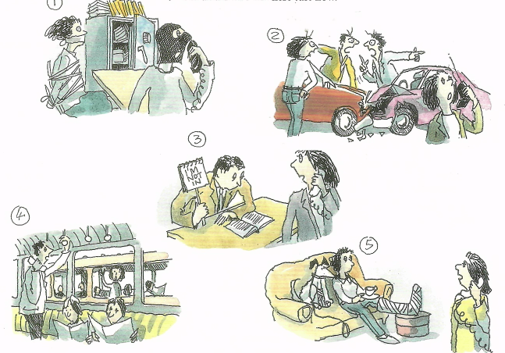

Can you think of any more reasons?

3. Work with a partner. Make up conversations deciding what to do when someone is not available.
A: Could I speak to Barbara Morey, please?
В: I’m afraid she’s on holiday this week.
A: Can you ask her to ring me next week?
B: Yes, certainly.

These phrases will help you.
I’ll hold.
I’ll call back later.
Could you take a message?
Could you give her a message?
Can you put me through to her secretary?

R e q u e s t s

Learn the following words and word combinations.

1. request – просьба
louder – громче
to repeat – повторять
fast – быстро
slowly – медленно
to transfer – переводить
2. to reply – отвечать
expression – выражение
surname – фамилия
password – пароль
to lend – одолжить (дать)
to borrow – одолжить (взять)
3. Help yourself. – Угощайся.
to invite – приглашать
4. customer – покупатель
supplier – продавец
delivery – доставка
to deliver – доставлять
invoice – счет, накладная
discount – дисконт, скидка
5. enquiry – запрос
lap-top – переносной
terms – условия
payment – оплата
to invent – изобретать
to agree – соглашаться
to refuse – отказываться
to forget – забывать

1. We use these phrases to ask other people to do things.
Can you ... ? Could you ... ? Would you ... ?

You’re on the phone. What do you say in these situations?
a) You can’t hear the other person.
b) You want them to repeat something.
c) They are speaking too fast.
d) You want them to spell a word.
e) You want them to transfer you to the Finance Department.

2. We can reply to requests like this.

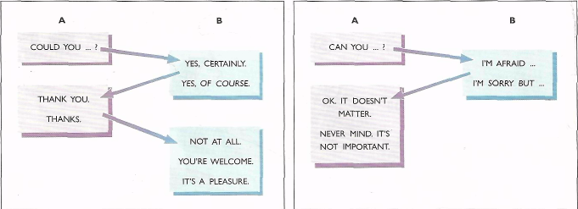

3. Practise these expressions with a colleague. Ask them to:
a) spell their surname for you.
b) tell you the time.
c) tell you their computer password.
d) give you a lift home tonight.
e) lend you their dictionary.
f) lend you some money.

Vocabulary note

We lend to someone and we borrow from someone. So when we lend, we give; and when we borrow, we take. Put “lend” or “borrow” in these questions.
Could I … some money?
Could you … me some money?

3. We use these phrases to ask if it’s OK to do things.
ASKING SAYING YES SAYING NO
Can I ... ? Yes, please do. I’m afraid you can’t...
Could I ... ? Of course. I’m sorry but you can’t...
May I ... ? Yeah, go ahead. (informal)
Help yourself. (inviting someone to take something)

Practise with a colleague. You are in their office and you want to:
a) use their phone
b) smoke
c) look at their copy of the production plan
d) copy a file on their computer
e) borrow their copy of the Economist
f) borrow their car.

4. Who makes these requests: a customer (C) or a supplier (S)?
1) Can I place an order?
2) May I have your name and company name?
3) Could you tell me the delivery address?
4) Can you deliver next Friday?
5) Could I have an address for the invoice?
6) Could you tell me how much it will cost?
7) May I have a discount?
8) Would you confirm this order in writing?

Work with a partner. Make up a conversation between a customer and a supplier. Use as many requests as you can.

5. Work in pairs. Look at the information below.
One of you is a supplier of computers, you sell computers. A foreign customer phones you. Answer their enquiries about your lap-top computer, the NC-200. They will ask about: your prices, delivery times, the guarantee, discounts, your terms of payment. Invent your answers. You can agree to or refuse their requests. Don’t forget to write down their details.
The other one is a customer. Telephone a foreign supplier and ask them to:
• supply you with 40 lap-top computers NC-200;
• quote you a price GIF; • deliver in one month;
• give you a two-year guarantee;
• give you a 20% discount; • give you 60 days to pay.
III. S k i l l s w o r k

L i s t e n i n g

Learn the following words and word combinations.

1. the rest – остальной
tone – гудок
to reach – связаться
urgently – срочно
to page – сбросить на пейджер
2. make notes – записать
to correct – исправить
appointment – назначенная встреча
to set up – назначить
3. to confirm – подтверждать
arrangements – приготовления, планы, договоренности
4. voice mail system – автоответчик
5. to press – нажать
to replay – проиграть еще раз
to delete – удалить
to transfer out – выйти
pound key (=hash key)– нижняя
правая клавиша

1. Tape 6a. Listen to a message on a telephone answering machine and answer these questions.
a) Where is Anne Parker going?
b) How can you reach her?

2. Tape 6b. One of Anne’s colleagues listened to Anne’s messages and made notes. Listen to the call, find the mistakes in the note below, and correct them.

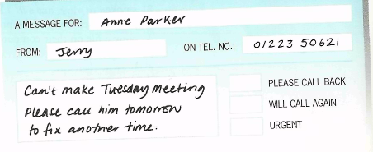

3. Tape 6c. Now listen to another caller and complete this message.

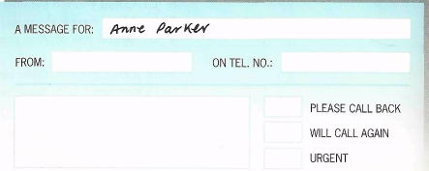

4. Tape 6d. Listen to a different recorded message. Who is it for and what is their extension number?

5. Tape 6e. Listen to some more voice mail instructions. What number do you need to press to:
a) replay a message?
b) continue recording a message?
c) delete a message?
d) speak to an operator?
e) transfer out of the voice mail system?

S p e a k i n g

Learn the following words and word combinations.

to act out – разыграть
still – все еще
to expect – ожидать
current –текущий

Sit back to back with a partner and act out these telephone calls. Look at the information below.
Call 1

A:
Your company’s new price lists are still at the printers. You expect them to arrive today. A customer calls with a request. Write down the details.
B:
Phone your partner and ask him/her to send you an up-to-date copy of their company’s price list. Don’t forget to give your name and address.

Call 2

A:
Phone your partner and ask them to speak at the GMB Congress at Queen Margaret’s Hall, Manchester on July 13th. You want them to give a talk on their company’s current projects.
B:
Your partner phones you with a request. Say yes and write down the details.

W r i t i n g

Learn the following words and word combinations.

1. grateful – благодарный
as soon as possible – как
можно скорее
sincerely – искренне
reference – ссылка
procurement – поставка
2. list – список
faithfully – с почтением
wishes – пожелания
truly yours – преданный вам
suitable – подходящий
close – близкий
advertisement – объявление
to enquire – узнавать,
навести справки
to apologize – извиниться
be delighted – быть в восторге
unfortunately – к сожалению
to enclose – вкладывать
closing – заключительный
to look forward – ожидать,
надеяться на

1. We often write letters to confirm phone calls. Most business letters and faxes contain a lot of standard phrases. Notice how some standard phrases are used in this letter.

FOTOTECHNIQUE
31, rue de Constantine 16102 Cognac Cedex
Telefax: 45 39 16 11 Fax: 790 962 F Tel: 45 39 29 24

Mary Thatcher
Sales Manager
Galaxy Computer Supplies
221 Hills Road
Cambridge CB2 2RW

27 October 2010

Dear Ms Thatcher,
With reference to our telephone conversation today, I am writing
to confirm our order for: 10 x Photoconductors Ref. No. 76905 A/K.
I would be grateful if you could deliver them as soon as possible.
Thank you for your help.

Yours sincerely,
Christophe Terrien
Director - Procurement.

2. Study and use this list of standard phrases to complete the letters below.

THE START THE FINISH
Dear Sir or Madam, * Yours faithfully, *
Dear Mr Sloan, ** Yours sincerely, **
Mrs Sloan, ** Best wishes, ***
Miss Sloan, ** AMERICAN ENGLISH
Ms Sloan, ** Sincerely yours,
Dear Mary-Lynn, *** Yours truly,
* suitable if you don’t know the name of the person you are writing ro.
** suitable if you know their name.
*** suitable if the person is a close business contact or friend.
THE REFERENCE
With reference to your advertisement in the “Reporter”,...
your letter of 25th April, ... / your phone call today, ...
THE REASON FOR WRITING
I am writing to enquire about ... / apologize for ... / confirm ...
REQUESTING AGREEING TO REQUESTS
Could you possibly ... ? I would be delighted to ...
I would be grateful if you could ...
GIVING BAD NEWS ENCLOSING DOCUMENTS
Unfortunately ... I am enclosing ...
I'm afraid that ... Please find enclosed ...
CLOSING REMARKS
Thank you for your help.
Please contact us again if we can help in any way. / there are any problems. /
you have any questions.
REFERENCE TO FUTURE CONTACT
I look forward to hearing from you soon. / meeting you next Tuesday. /
seeing you next week.
LETTER 1
GEO ORT LTD
Tel: 01525 72245 Fax: 01525 72611
Dear Mr Cochet,
……………………(1) phone call today, ……………… (2) for not sending you our price list. …........................................ (3) , it is still at the printers .
However, …......................................... (4) a copy of the old list with the new prices 34enciled in.
……………………. (5)
……………………., (6)
Jacqueline Scott.
LETTER 2
GEO ORT LTD
Tel: 01525 72245 Fax: 01525 72611
Dear Mary,
…………………………… (1) your phone call yesterday.
…………………………… (2) to confirm that …………………… (3) come and speak at the GMB Congress in Manchester on July 13th.
…………………………… (4) send me a map showing how to get to Queen Mary’s Hall?
…………………………… (5)
……………………………, (6)
Jacqueline Scott.
3. Study how business letters are organized.

a letterhead / address (but not name) of the writer (фирменный бланк /
адрес отправителя, без имени)
b name and address of recipient (имя и адрес получателя)
c references (ссылки на кого-либо, что-либо)
d date (дата) e opening (вступление)
f subject heading (главная тема) g body of the letter (само письмо)
h closing (заключение) i signature (подпись)
j name and job title (имя и занимаемая должность)
k enclosures (вложение, приложение)

Sample Letter

a T e c h S t a r t
Karelstraat 137
1051 Amsterdam
Netherlands
Tel. 00 31 20 98 74 63 35
b Carl Mays, Robert Ingram, Maria Ibanez
Stanfield Business School
Rochester
RC5 7JY (ZIP Code – in USA, почтовый индекс)
United Kingdom
c Our ref: TSBA/DK/136
d September15th 2009

e Dear Carl, Robert and Maria,
f Re: Confirmation of award (Подтверждение присуждения награды)
pp: … (= per proxy, on behalf of – по поручению)

g I am very pleased to announce that the project that your team presented to
the annual TechStart business award committee has been selected as this
year’s winner. Congratulations to you all for your excellent Rainbow
Systems project.
It is a great pleasure for me to be able to confirm this award. We will be
arranging a meeting in late October. I am enclosing three invitations for the
award ceremony, which will be held at TechStarfs head office on October,7.
I look forward to seeing you on the 7th October and to having the pleasure
of presenting you with the award in person.

h Yours sincerely, (С уважением,)
i Dave Kloren (подпись)
j Dave Kloren
Chief Executive (исполнительный директор)
k enc.
4. Study how addresses are written on envelopes.

Отправитель, обратный адрес
(the sender, the return address)

- название фирмы (the sender’s name)
- номер дома, улица (the house number, the street name in the return address)
- город (the town the letter comes from)
- индекс (ZIP Code in the return address)
- страна (the country, the state the letter comes from)

Получатель, почтовый адрес
(the addressee, the mailing address, delivery)

- имя, фамилия / фирма (the addressee / attention line)
- название фирмы (company’s name)
- номер дома, улица (the house, the street / the suite number)
- город (the town the letter is sent to)
- индекс (ZIP Code, mailing address)
- страна (the country the letter is sent to)

5. Study how curriculum vitae is usually written.

Curriculum vitae = CV = resume (USA) = brief personal history (резюме).

Name Mirjam Brigitte Ott
Address Landstrasse 482, CH 5962 Zurich, Switzerland
Place of Birth Zurich
(место рождения)
Nationality Swiss, Father German, Mother French
Age (Возраст) 22
Marital Status Single
Education 11 years Swiss state school,
(Образование) 1 year Euro centre (Евро центр),
passed Cambridge Certificate of Proficiency in English
(владение английским),
1 year Secretarial College with emphasis on (с
углубленным изучением) book-keeping (счетоводство)
and accountancy (бухгалтерское дело)
Languages Fluent (бегло) French, German, Italian
Previous experience 2 years in father’s office – father is a jeweler (ювелир)
Interests Travel, art, skiing, ballet
6. Study how emails are to be written.

a name of the person sending the email (имя отправителя)
b name of the person / people the email is addressed to (имя получателя)
c cc (= carbon copy) person / people who will also receive the mail though it
is not addressed directly to them (кому еще будут отосланы копии)
d bcc (=blind carbon copy) person / people who will receive a copy without
other people knowing («слепая копия», получателю «слепой копии»
недоступен весь список адресатов рассылки)
e date and time (дата и время отправления)
f subject (предмет написания), re (=regarding – относительно чего-то),
information about the content of the email (содержание, главная тема)
g files, documents, etc. sent separately rather than included in the actual
message or body of the email (приложение, прикрепление)
h opening (вступление)
i body of the email (само электронное сообщение)
j closing (заключение)
k name and job title (имя и должность отправителя)

Sample Email (Formal)

a From: Sarah Bates, Personal Assistant
b To: Tom Peterson
c Cc: Alan Hickson, Production Manager
d Bcc: Katia Belmondo, Managing Director (главный менеджер,
управляющий, директор-распорядитель)
e Sent: 12 January 200_ 14:54
f Subject: Re: Request for dispatch confirmation (просьба о
подтверждении отправки товара)
g Attachment: Invoice doc (счет-фактура)

h Dear Mr Peterson
i Thank you for your mail. I have checked (сверился) with Mr Hickson, our
Production Manager, and I can confirm that the 200 cases (контейнеров,
ящиков) you ordered (заказали) left our warehouse (склад) yesterday and
should arrive (должны прибыть) at their destination (в пункт назначения)
by tomorrow at the latest. Please let me know if there is any delay
(задержка). I am sending a copy of the invoice as requested (согласно
вашей просьбе), in the attached file (в прилагаемой папке).

j Yours sincerely,
k Sarah Bates
Personal Assistant (личный секретарь)

7. Study how faxes are to be written.

a letterhead (шапка на фирменном бланке)
b name of the person / people who will receive the fax (имя получателя)
c name of the person / people sending the fax (имя отправителя)
d sender’s fax number (номер факса отправителя)
e date (дата)
f total number of pages (общее количество страниц)
g opening (вступление)
h body of the fax (текст факса)
i closing (заключение)
j signature (подпись)
Sample Fax

Central Hotel
a 194 Eastern Avenue
London, WC1 4AT
Tel: 020 798301

b TO: Christopher Hardy, PA
c FROM: Lynda Martel, Purchasing Manager
d FAX NUMBER: 020 755660
e DATE: Wednesday, 3rd April
f NUMBER OF PAGES: (including this – включая эту): 3

g Dear Christopher,
h Thank you for your fax and thank you for looking after things so well
(хорошо присматриваешь за делами) while I’m out of the office. I’ve
decided to stay on an extra day to catch another fashion show and I’d
like you to do the following:
• Cancel (отмени) tomorrow’s taxi and arrange for (договорись, закажи)
one same time Friday morning.
• Send reminders (напомни) about Friday afternoon’s Product Managers’
meeting to all participants (участникам).
• Photocopy (сделай ксерокопию) one copy of the attached
(прилагаемого) price list and catalogue for each participant.
• Contact (свяжись с) Jeff Murrey from Finance and ask him if he can
come. Tell him I’m bringing samples (образцы) and prices of the new
lines I think we should buy.
• Email Mr Cameron and explain (объясни) why I’m coming back a day
late.
See you Friday around 10am.
i Regards, (с наилучшими пожеланиями)
j Lynda Martel
8. Study how memos (служебные записки) are to be written.

a date (дата)
b name of the person / people the memo is addressed to (имя адресата)
c name of the person / people sending the memo (имя отправителя)
d information about the content of the memo (главная тема)
e introduction to the subject matter (вступление)
f main points (основные вопросы)
g conclusion, often recommending the action to be taken (заключение,
рекомендуемые действия)
h closing, which can be the name or initials of the person sending the memo
(заключение, часто просто инициалы отправителя)

Sample Memo
Qualcom Industries

a DATE 9th June
b TO All Marketing staff
c FROM Alan Stewart, Marketing Manager (менеджер по
маркетингу)
d SUBJECT New product launch (выпуск нового товара)

e I am delighted to inform you that the Finance Committee has approved
(одобрил) the new product plans (план нового продукта). We need to get
moving (взяться) ASAP (как можно скорее) on the marketing campaign
(маркетинговая кампания).
f • Could you send (выслать) me all the present market research data
(данные) on the identified target (установленные плановые
показатели).
• I recommend we set up (собрать, организовать) focus groups (фокус-
группы) for more up-to-date data (новейшие данные).
• I would like to see a selection (подборку) of proposed (предлагаемых)
brand names by the end of this week.
• The creative team (творческая группа) must have a proposal for a print
media (печатные средства массовой информации) and TV campaign
by the end of this month.
• We need to finalise (все завершить) and make decisions (принять
решения) at the next meeting early next month.

g Make (предоставьте) this project an urgent priority (внеочередной
приоритет). The team must meet the above deadlines (уложиться в
вышеупомянутые предельные сроки).

h A.S.
UNIT 2
WORKBOOK

Learn the following words and word combinations.
vowel – гласный
sound – звук
different – отличающийся

1. Pronunciation. a) Match the letters that have the same vowel sound.

1) B a) U
2) I b) P
3) D с) Y
4) Q d) К
5) M e) G
6) J f) S

b) Match the letters with a word that has the same vowel sound.

1) О a) free
2) R b) pay
3) U с) cat
4) V d) toe
5) I e) shoe
6) J f) fly

c) Now look at the abbreviations below. They are grouped by sound. Find the abbreviation which sounds different from the other three.
Example: CBI BDI РТУ PTE (Tne last sound is different)
GDP PST GMT GNP
MIT NEC NYC FIT
VAT CAP BKG PLC
EGM GIF DCF PPS
COD ВОТ FOB POD

Learn the following words and word combinations.
comment – высказывание
reply – ответ
while – пока, в то время как

2. Making calls. Match these comments to their replies.
1) Sorry, could you spell that? a) Yes, it’s 0181 432 9191.
2) Could I speak to Mrs Fenton, please? b) That’s OK. I’ll hold.
3) Could you take a message? c) I’ll call back next week, then.
4) I’m afraid the line’s busy at the moment. d) Speaking.
5) I’m sorry but he’s away this week. e) Yes of course. I’ll get a pen.
6) Could you repeat that? f) Yes, it’s M-E-E-U-W-S.

Learn the following words and word combinations.
to choose – выбрать
italics – курсив
engineering – машиностроение
broken – сломана
engaged – занята
paint shop – художественная мастерская
to regret – сожалеть
3. On the line. Choose the correct words in italics to complete the telephone conversation.
A: Fenton Engineering.
В: Number / Extension ¹ 473, please.
A: I'm afraid the line’s broken / engaged². Will you hold?
В: Yes.

A: The line’s free now. I’ll put / connect³ you through.
В: Thank you.
С: Paint shop.
В: I’d like to speak to Mrs Isaacs.
С: Who’s / Whose⁴ calling, please?
В: Jacques Duval.
С: Wait /Hold on⁵ M Duval. I’ll bring / get⁶ her.

С: I’m afraid / regret⁷ she’s in a meeting. Do you want to call up / back ⁸ later?
В: No, it’s urgent. Could you leave / take ⁹ a message?
С: Yes, I will / of course ¹⁰.
В: May / Could ¹¹ you ask her to call me back?
С: Does she have your number?
В: No. It’s Paris – the code / area ¹² is 00331 then the number is 46 58 93 94. Could you say / read ¹³ that back to me?
С: 00 331 46 58 93 94.
В: That’s right.
С: Anything / What¹⁴ else?
В: No, that’s anything / all¹⁵. Thank you very much.
С: You’re welcome / fine¹⁶.
В: Goodbye.

4. Requests. a) Put these phrases into two groups:
Could you ...? Can I ...? Would you …?
May I ...? Can you ...? Could I ...?

asking other people to do things
__________________________
__________________________
__________________________
asking if it’s OK to do things
________________________
________________________
_________________________

b) Use the phrases from Part A in sentences below.
Example: What would you say to a customer if you wanted to use their phone?
May I use your phone?
What would you say:
1) to ask a friend to tell you the time?
___________________________________
2) to a colleague if you wanted to smoke in their office?
_____________________________________________
3) if you wanted a friend to give you a lift to the station?
_____________________________________________
4) if you want to borrow your boss’s copy of the production plan?
____________________________________________________
5) if you wanted to copy a file from a colleague’s computer?
________________________________________________
6) if you wanted a colleague to lend you a book?
_______________________________________

5. Wordcheck. Complete the puzzle and find the keyword in 14 down.
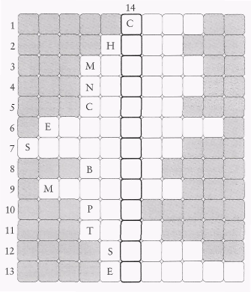
Across
1) I’ll _____ back later. (4)
2) The line’s busy. Will you _______? (4)
3) Could you hold on a _________ and I’ll get a pen. (6)
4) My new _________ will be 0171 335 2378. (6)
5) ________ I leave a message? (5)
6) May I have __________ 3285, please? (9)
7) Good afternoon. Paul Moran __________. (8)
8) I’ll ask Mr Travers to call you _______ as soon as possible. (4)
9) Would you like me to take a __________? (7)
10) Could you ______ me through to Miss Nixon, please? (3)
11) Good morning, _______ is Richard Bowers. (4)
12) I’m _________, but Mr Laws is away all week. (5)
13) The line is ___________. Can I ask her to call you back? (7)
Down
14) One of the keys to successful management. (13)

Learn the following words and word combinations.

to arrange – организовать
to recommend – рекомендовать
booking – заказ (билетов, номера)
to show round – показать (город)
deputy – заместитель
particularly – особенно
most – большинство
in any way – всеми способами

6. Writing letters. a) Complete the following letter using the correct word or phrase from the list below.
a) I would be grateful ...
b) Thank you for your help.
c) I look forward to hearing from ...
d) I am writing to confirm ...
e) Could you possibly ... ?
f) Yours ...
g) With reference to ...
Dear Mr Hendrikson,
________________ ¹our telephone conversation today, ______________² that I will be in Sweden from 11-14 June. _____________________³ if you could arrange for me to visit the Technical Department in Stockholm. If possible, I would also like to meet Mr Elmqvist. ___________⁴ also send me a list of any hostels near Head Office that you would recommend, and I will make the bookings from here?
___________________⁵
___________________⁶ you.
___________________⁷ sincerely.
__________
M K Vernon

b) Now complete the reply using a word or phrase from the list below:
a) I am afraid that ...
b) Please contact us again if ...
c) Thank you for your letter of ...
d) I am enclosing ...
e) I would be delighted to ...
f) ... sincerely
g) I look forward to meeting you ...
h) I am writing to ...

Dear Mr Vernon,
___________________¹ May 21.
___________________² give you details of the arrangements for your visit.
___________________³ show you round the Technical Department when you
arrive. I have arranged a visit for Monday June 12 at 11.00 am.

___________________⁴ Mr Elmqvist will not be here when you come, but his
deputy, Mr Karlsbad, will be pleased to meet you.
___________________⁵ a list of hotels near Head Office. I would particularly recommend the Sheraton, which most of our visitors enjoy.
___________________⁶ we can help in any way.
___________________⁷ in June.
Yours ______________⁸
______________
K K Hendrickson

Learn the following words and word combinations.

1. extract – отрывок
number plate – номерной знак
robber – грабитель
robbery – ограбление
vehicle – транспортное средство
2. to wait – ждать
to avoid – избегать
unwelcome – нежелательный
to agree – соглашаться
3. to hate – ненавидеть
answering machine – автоответчик
4. darling – дорогой
post – почта
right away – прямо сейчас
lovers – влюбленные
to pretend – притворяться
customer – покупатель
client – клиент
5. unit – единица, (зд.) минута
phone box – телефон-аппарат
to cut off – прерывать
phonecard – телефонная карта
to run out – кончаться
6. all in all – в целом
legal – юридический
fee – плата
reasonable – разумный
joke – шутка
lawyer – юрист
to misunderstand – неправильно понять
to realize – понять
actually – в действительности
to expect – ожидать

7. Reading. Read these extracts from telephone calls. Who do you think is talking? What do you think they are talking about?
1) A: I’ll see you outside the bank at 11.30 then.
В: No, I said 11.28.
A: OK, 11.28.
В: And don’t forget to change the number-plates.

2) A: It’s Mr Carter on line 4.
В: Not again! Could you tell him I’m busy, Mary.
A: I did, but he says he’ll wait.
В: Oh, all right then. Put him through.

3) A: I’m afraid no one is available to take your call.
В: Oh no, I hate these things.
A: Please leave your name and number after the tone.
В: Er hello ... er ... I’ll call back later.
4) A: Darling, it’s me. Can you talk?
В: Wait a minute. Yes, I think so, but be quick.
A: I can’t stop thinking about you.
В: Thank you for calling, Mr Jackson. I’ll put a catalogue in the post for you right away.

5) A: I’m on my last unit.
В: Hold on, Jane, I’ll get a pencil ... OK.
A: I’m on 0181 ...
В: Oh no!

6). A: All in all the legal fees come to £30,000.
В: That’s very reasonable. That’s one three, I hope.
A: No, Mr Brown, three zero, I’m afraid.
В: What? For three weeks’ work? You must be joking!

8. Read these letters and decide what kind of business letters they are. (Contract, Memo, letter of enquiry / request, letter of complaint, letter of apology, letter of application …)

a) Dear Sirs,
We have received your letter dated the 20th March and were glad to learn that you want to contact with us.
According to your request we send you samples of our goods. We hope that you’ll like the samples and you’ll place an order in our company.
The prices are given in the price list, which is enclosed with the letter. The terms of payment are the following: the purchaser opens an irrevocable letter of credit to the seller in … bank in Moscow at the overall goods cost.
The letter of credit must be opened within 5 days from the date of notification of the readiness of the goods for shipping. The payment is made against the shipping documents.
Yours faithfully…

b) Dear Sirs,
Thank you for your inquiry and we are glad to send you our proposal and models which interest you.
We offer goods at the prices stated in the catalogue, which is enclosed with the letter. Please, acknowledge the receipt of our proposal within 10 days from the date of the letter.
The terms of payment are the following: 70% of good value is paid at an irrevocable confirmed letter of credit at sight of the shipping documents. The rest 20% are paid after the delivery.
The letter of credit must be opened in … bank in Moscow and must be valid within 60 days.
Sincerely yours …
c) Dear Sirs,
We acknowledge that unfortunately your terms don’t suit us. Though if you agree to reconsider prices and give us 2% reduction, guarantee immediate delivery, prolong the warranty period and pay for the insurance, we are ready to consider your offer once again and place an order in your company. We are even ready to increase it at several points and it’ll depend on the final price.
We have been running business with you for several years and have always been good partners. Hope that this time you will be able to comply with our request and make concessions.
Yours truly….

d) In the winter issue of Multimedia News we read that your company sells language laboratories. Our school needs a new language laboratory and we are looking for the best equipment.
Could you please send us information on your laboratories and include a price list and ordering information. Thank you for your assistance.
I look forward to hearing from you.

e) Dear Akram,
Thank you for your fax. I was sorry to hear that you’ve had some problems with the WR 458. We do all we can to make sure that our product leave our factory in perfect condition, but unfortunately sometimes a bad one does slip through. If you can arrange for it to be returned to me, I’ll let you have a replacement by return. Hoping that you are keeping well,
Regards
Tony

f) Dear Sirs,
Please quote us your most favourable freight rates for the transport of 50 tonnes of palletized house bricks, net weight 1 tonne per unit, for shipment from Southampton to Tunis in the first two weeks of December.

g) Dear Mr. Rook,
I’m applying for the position of the clerk which was advertised in the July 16 Publisher’s Monthly. I’m enclosing my CV and some recommendations.
Yours faithfully,
Frederick Fox.

h) We are a large record store in the centre of Manchester and would like to know more about the CDs and DVDs you advertised in last month’s edition of Hi Fi. Could you tell us if the products are leading brand names, or made by small independent companies, and if they would be suitable for recording classical music, games and video?
We would appreciate it if you send us some samples.
UNIT 3
COMPANIES
Objective: to discuss the business activities of companies.
Tasks: to describe current projects, to exchange numerical information, to ask and answer, questions about facilities, to give a presentation of your company.

I. P r e s e n t a t i o n

Learn the following words and word combinations.

1. product – продукция, продукт
to produce – производить
to provide – снабжать,
обеспечивать, заготавливать
activity –деятельность
3. employee – служащий
quarter – четверть
subsidiary – дочерняя компания
over – сверх, более
worldwide – по всему миру
altogether – всего, вместе
turnover – оборот
to locate – располагаться
parent company – головная (родительская) компания
consumer – потребитель
joint venture – акционерное общество
to expand – расширять
to develop – развивать
venture – контакты
4. to carry – перевозить
to fly – летать
destination – направление
domestic – внутренний
service – рейсы, обслуживание
to serve – обслуживать, снабжать
route – маршрут
safety – безопасность
priority – приоритет
currently – в данный момент
to install – устанавливать
aircraft – самолет, авиация
device – прибор, устройство
to improve – улучшать
communications – связь, общение
to reduce – сокращать
air traffic – возд.транспорт, грузы
congestion – перегруженность
satellite links – космическая связь
5. advanced – передовой
processing – обработка
data storage – хранение данных
field – область
exciting – захватывающий
to throw out – выбрасывать, избавиться
to introduce – вводить
billion – миллиард
to encourage – поощрять
to happen – происходить

1. What products or services do these companies provide? Do you know anything about their activities?
a) JAL (Japanese Airlines), b) Philips, c) IBM (International Business Machines)
2. Tape 7. Listen to three people talking about these companies. Which
company are they talking about?

3. Tape 7a. Listen to the first speaker again. Make notes on the company.
Employees: ______________________
Subsidiaries: _____________________
Turnover: ________________________
Location of parent company: _________________________
Number of products: ________________________________
Joint venture partner: ________________________________

4. Tape 7b. Listen to the second speaker again. Complete these notes.
30,000,000 _____________ a year.
Fly to 41 _____________ in 25 _____________ ____________.
Domestic service has 48 _________ and serves 20 _________.
___________ is their number one priority.
Currently _________ _______________ FANS in their aircraft.
FANS are __________ communications and __________ air traffic congestion.

5. Tape 7c. Listen to the third speaker again and answer these questions.
1. What’s the company’s turnover?
2. How many employees are there?
3. What’s happening in the company at the moment?

II. L a n g u a g e w o r k
C o m p a n y p r o f i l e s

Learn the following words and word combinations.

engineering – машиностроение
profit – прибыль, доход
joint venture – совместное предприятие
site – площадка, место
distribution – распространение
sales – продажа
wood supply – поставка леса
fleet – флот
schedule – расписание
affiliate – филиал
overseas – за рубежом
core – ключевой
tyre – шина
cable – кабель
major – главный
brand – торговая марка
around – около
associated – объединенный

research – исследование

1. Look at these two different ways of asking and answering question with the verb “have”.
1) A: How many employees has Philips got?
B: It has got 250,000.
A: Has it got any factories in Slovenia?
B: No, it hasn’t.

2) A: How many subsidiaries does Philips have?
B: It has over 120.
A: Does it have a subsidiary in the UK?
B: Yes, it does.
2. Work with a partner. Ask and answer questions about these companies.
a) Aussedat Rey Group (paper)
9 industrial sites in France and 1 in Spain.
1 distribution company in France and 1 in Holland.
7 European sales subsidiaries.
1 wood supply subsidiary.
b) ABB (electrical engineering)
206,000 employees.
1300 companies.
Over 5,000 profit centres.
11 joint ventures in China.
c) ANA (airline)
123 aircraft in the fleet.
119 scheduled routes.
163 affiliates and subsidiaries.
41 hotels with 12 overseas.
d) Carlsberg A/S (beer)
2 major brands: Carlsberg and Tuborg.
60 production sites.
Around 100 subsidiaries and associated companies.
80 laboratories at the Carlsberg Research Centre.
e) Pirelli (tyres and cables)
2 core businesses: tyres and cables.
78 factories.
Over 41,000 employees.
2,000 research and development specialists.

F a c i l i t i e s

Learn the following words and word combinations.

2. similar to – похожий
plants – растения
bookcase – книжный шкаф
tidy – аккуратный
3. staff – штат, пресонал
facility – приспособление
disabled – инвалиды
noisy – шумный
separate – отдельный
nearby – поблизости
creche – детские ясли
recreation – отдых

1. Would you like an office like this? Why? / Why not?

2. Make sentences about the office. Begin:
It’s ... It isn’t ...
There’s a ... There isn’t a ...
There are some ... There aren’t any ...
Use the following words:
computers, plants, coffee machine, small, dark, map, photographs, bookcase , very tidy, windows, water fountain, similar to my office, child, TV, coffee machine, telephone, fax, radio set, clock …
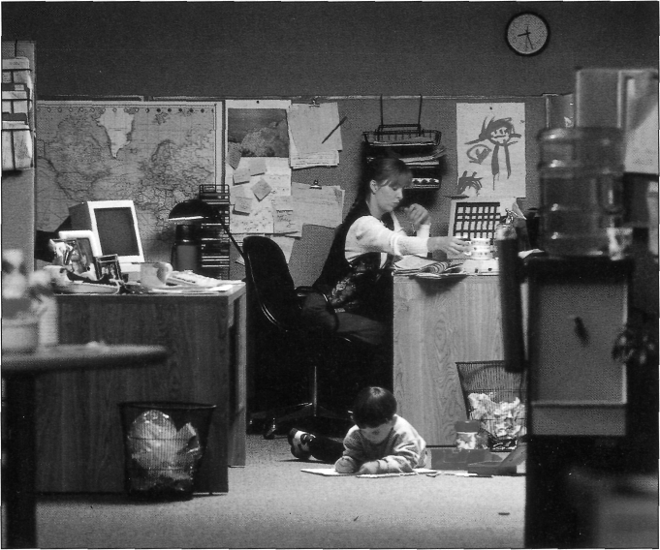
G r a m m a r n o t e
- We use there is and there are to say things exist or don’t exist. There’s a child’s picture on the wall but there aren’t any plants in the room.
- We use it for things. The picture is on the notice board. It’s orange.
- So we often use there when we talk about something for the first time and it when we describe the details. There's a water fountain by the wall. It's two thirds full.

3. Find out about a partner's place of work. Ask questions about the building and its facilities. Use the words below and begin:
Is the building ... ? Is there a(n) ... ? Are there any ...?

- modern
- staff restaurant
- facilities for disabled staff
- lifts
- noisy
- air conditioning system
- cold in winter
- separate rooms for smokers
- large car park
- near a railway station
- bus stops nearby
- creche
- sport or recreational facilities
- nice to work in

P r o n u n c i a t i o n
1. Tape 8a. There are three ways to pronounce “s” at the end of words: [s], [z], and [iz]. Practise saying these words.

 | SINGULAR | PLURAL
[s] | mistake  product | mistakes  products
[z] | employee  sale | employees  sales
[iz] | box  package | boxes  packages

2. Tape 8b. Now listen to some verbs. They all end with “s”. Which ones end with an [iz] sound?

1) puts
2) places
3) pays
4) purchases
5) sells
6) plans
7) services
8) arranges
9) recruits
10) manufactures
11) invoices
12) looks after
13) dispatches
14) organizes
15) deals with

O r g a n i z a t i o n s

Learn the following words and word combinations.

wages – зарплата
salary – жалованье
packaging – упаковка
quality – качество
maintenance – текущий ремонт
advertising – реклама
buying – покупка
customer – покупатель
accounts – счет
a) department – отдел
crate – ящик
b) ad – реклама
c) to pay – платить
d) to purchase – покупать
e) to sell – продавать
g) equipment – оборудование
h) to arrange – организовывать
i) to recruit – нанимать на работу
j) to manufacture – производить
k) to invoice – выписывать счет
to look after – рассматривать
l) complaint – жалоба
m) to dispatch – отправлять
n) to prevent – предотвращать
o) to deal with – иметь дело с
taxation – налоги
investment – вложения
cash – наличные средства
management – управление
supply – предложение, запас

Study this organization. Which department:
a) puts the products in boxes and crates? b) places ads in magazines?
c) pays the staff? d) purchases supplies?
e) sells the products to customers? f) plans how to sell new products?
g) services the machines and equipment? h) arranges courses for the staff?
i) recruits new employees? j) manufactures the products?
k) invoices customers? 1) looks after customers’ problems and complaints?
m) dispatches the products and sends them to customers?
n) organizes control systems to prevent mistakes?
o) deals with taxation, investment, and cash management?
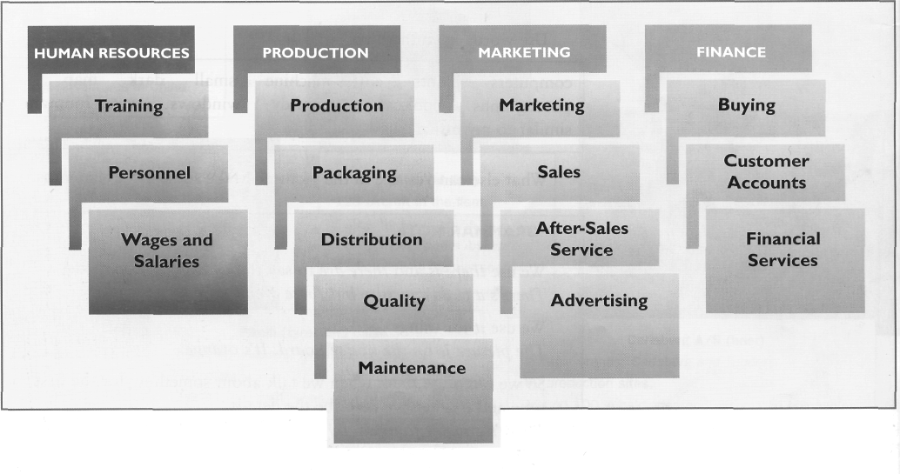
C u r r e n t a c t i v i t i e s

Learn the following words and word combinations.

1. to wait – ждать
to call – звонить
to get – подходить, становиться
to expand – расширять
to develop – разрабатывать
to stay – оставаться
drug – лекарство
order – заказ
life cycle – жизненный цикл
IT – information technology
2. to enter a market – вступать,
завоевывать рынок
division – подразделение
to take on – принимать (на работу)

1. We use the Present Continuous tense to talk about actions that are going on at the moment. Complete these sentences using the following words:
wait, get, call, go, spend, build, develop, expand, stay.
a) Philips are expanding their activities in China.
b) Our research department _____________ a new drug.
c) They _____________ at the Dorchester Hotel.
d) Someone _______________ for you in your office.
e) We______________ a new factory in Barcelona.
f) I _______________ about order no. AJ/2496.
g) These products ________________ near the end of their life cycle.
h) The dollar_______________ up.
i) The IT department____________ a lot of money on new equipment at the moment. (IT – Information Technology)
G r a m m a r n o t e
- We use the Present Simple tense (V1 / Vs) to talk about regular activities. The maintenance department services the equipment.
- We use the Present Continuous tense (am / is / are + Ving) to talk about temporary activities. The IT department is spending a lot of money at the moment.

2. Work with a partner. Find out what’s happening in their company at the moment.
a) Are they entering any new markets? (Which ones?)
b) Are they developing any new products or services? (What?)
c) Are they building any new facilities? (What? Where?)
d) Are they working in any joint ventures? (What?)

And what’s happening in their department or division?
a) Are they taking on new staff? (Why?)
b) Are they reorganizing any work systems? (Which ones? Why?)
c) Are they introducing a quality programme? (What exactly?)
d) Are they introducing new technology? (What?)

C o m p a n y s t r e n g t h s

Learn the following words and word combinations.

1. close – тесный
range –ассортимент, ряд
representatives – представители
main – главный
2. store – магазин
to charge – назначать
to prefer – предпочитать
to run – управлять
to find out – узнать
worldwide – по всему миру
Value – достоинства, ценность
to keep – держать
increasing – увеличение
share – доля

Advertising – реклама
annually – ежегодно

Training – обучение
to receive – получать
at least – по крайней мере
to attend – посещать
even – даже
own – собственный

Face-to-face meetings
headquarter – главный офис
still – все равно
the same – тот же самый

Relationships – отношения

supplier – поставщик
to make sure – быть уверенными
to meet – соответствовать
specifications – технология, детали
Cultural sensitivity –учет культуры
thoroughly – тщательно
to employ – нанимать на работу
local – местный
Customer service
burger – гамбургер
3. low – низкий
compared with – по сравнению с
competitor – конкурент
to hold – проводить
colleague – коллега
counterpart – партнер

1. Are these statements true for your company?
a) We produce high quality products.
b) We provide a high quality service.
c) We use the most advanced technology.
d) We are in close contact with the market.
e) We produce a wide range of products.
f) We invest a lot of money in research and development.
g) We have sales representatives all over the world.
h) We are market leaders.
Why is your company special? What is your company’s main strength?

2. What do you know about McDonald’s? Are these facts true or false? What do you think?
a) Three new McDonald’s stores open every day.
b) McDonald’s charge high prices.
c) McDonald’s spend more on advertising than anyone else.
d) There is a Hamburger University.
e) The company CEO has a computer in his office.
f) McDonald’s prefer American managers to run overseas stores.

3. Now read this article and find out.
SERVICE WITH A SMILE
Three new McDonald’s stores open somewhere in the world each day. There are now over 14,000 McDonald's stores worldwide and sales are over $23 billion. So how do they do it? What are the company’s strengths?
Value
McDonald’s keep prices low. They concentrate on increasing market share.
Advertising
McDonald’s spend $1.4 billion annually on marketing, more than any other company in the world.
Training
Every employee receives at least two or three days’ training and all managers attend regular courses. The company even has its own Hamburger University in Oakbrook, Illinois.
Face-to-face meetings
The company headquarters don’t have an e-mail system and there’s no computer in the CEO’s office but ideas still fly around. There are regular meetings between people in the same region and people in the same line of work.
Close relationships with suppliers
McDonald’s work closely with their suppliers to make sure they can meet the McDonald’s specifications.
Cultural sensitivity
Before they enter a new country’s market, they research the culture thoroughly. And they employ local staff if they can.
Customer service
The restaurants are clean, the service is quick and every McDonald’s burger comes with a smile.

3. Interview a partner about their company. Ask:
a) Are your prices low or high compared with your competitors?
b) Is advertising important to your business?
c) What training do your staff receive?
d) Do you hold regular meetings with your colleagues and counterparts?
e) Do you have close relationships with your suppliers?
f) Are your managers locals or foreigners?
g) Why do your customers like your products/service?

SKILLS WORK
L i s t e n i n g

Learn the following words and word combinations.

construction – разработка
fibre optic – оптиковолоконный
piping – трубопровод
wholesaling – оптовая продажа
medium – средний
voltage – напряжение,
проводимость
power – ток, электричество

Tape 9. A manager from BICC describes her company. Listen and complete the organization chart below.
COMPANY – BICC plc (public limited company).
MAIN BUSINESS ACTIVITIES – Construction and manufacture of the cables.
TURNOVER – (1) ______________________

DIVISION | BAL-  FOUR BEATTY | BICC CABLES | AUSTRA-  LASIA | (6) _____  ________  CABLES | BICC  CABLES  (7) _____
MAIN BUSINESS ACTIVITIES | (2) _____ | (3) _____  ________ cables | Cables, piping,  and wholesaling | Medium voltage power cables | Cable  products
TURNOVER | £1730m | (4) _____ | (5) ______ | £476m

S p e a k i n g

1. Prepare to make a short presentation about a company to the class.
You can talk about your own company or one of the companies from this unit. Write notes first. Don’t write sentences – just write key words and numbers. (Guess any information you don’t know.)

 | MY COMPANY | THE GROUP
Products/Services
Main customers
Locations (factories, branches, etc.)
Facilities (car park,
main building, offices, sport, recreation)
Size (no. of employees/turnover)
Main strength
Current projects
Other information? (marketing, advertising)

2. Now decide on the structure of your presentation. These phrases will help you order the information.
THE INTRODUCTION:
I’d like to tell you about ...
ORDERING INFORMATION:
I’ll begin with ... Now I’ll move on to turn to …
CHECKING UNDERSTANDING:
Is that clear? Are you with me? OK so far?
FINISHING:
Are there any questions? Thank you very much.

Use your notes to give the presentation and answer questions from your colleagues.
UNIT 3
WORKBOOK

Learn the following words and word combinations.

to match – подбирать пару
halves – половины
agreement – соглашение
terminal – пункт назначения
acquisition – победа, приобретение
authority – руководство
to strengthen – укреплять
to negotiate – вести переговоры
negotiation – переговоры
due to – благодаря, из-за
shortage – нехватка
space – место
to move – передвигать, перемещать
to establish – учреждать, создавать
to diversify – разнообразить

1. Current projects. a) Match the two halves of these sentences.

1. The British Airports Authority are building...
2. NCC are strengthening their position in Europe by making ...
3. BAT Industries and Pecs are negotiating ...
4. Due to the shortage of space, the Lonrho Group are moving their AGM ...
5. SKF are establishing manufacturing operations ...
6. Credit Agricole, a leading French banking group, are diversifying to provide ...
a. a joint venture agreement.

b. from Grosvenor House to the Barbican Centre.

c. new financial products.

d. a new passenger terminal at London Heathrow.

e. a number of strategic acquisitions.

f. in Eastern Europe.

b) Now write two sentences about your company's current activities.

Learn the following words and word combinations.

to complete – заканчивать
italics – курсив
to collect – собирать
Stock Exchange – фондовая биржа
just – только
I hope. – Я надеюсь.

2. Present Continuous. A journalist from the New York Times is phoning a friend in London. Use the Present Continuous tense. Complete the dialogue, using the following verbs: do, write, stay (x2), visit, collect.
Peter: Peter Warner speaking.
Hilary: Peter. Hello, this is Hilary.
Peter: Hilary, how nice to hear from you! Where ___ you _________ (1) from?
Hilary: London. I _____ ___________ (2) at the Hilton.
Peter: Really? What ______ you _________ (3) in London?
Hilary: I ______ _____________ some information for an article that
I _______ ___________ (5) about the London Stock Exchange.
Peter: That’s wonderful. Is David with you?
Hilary: Yes, he ______ ____________ (6) his London office at the same time.
Peter: How long ______ you both _____________ (7)?
Hilary: Just a week.
Peter: I hope you’ve got time to come and see us.

Learn the following words and word combinations.

Meeting rooms:
convention – конференция, съезд
auditorium – зрительный зал
exhibition – выставка
Services:
simultaneous – одновременный
facility – аппаратура
lobby –фойе

break – перерыв
receptions – прием
Hotels:
major – главный
facility – оборудование
How to get to the center:
helicopter – вертолет
less than – менее чем

3. Facilities.
THE MONTE CARLO CONVENTION CENTRE AND AUDITORIUM AT THE FOOT OF THE CASINO TERRACES OVERLOOKS THE PORT OF MONACO.
Meeting Rooms
- Congress Hall: seating for 1,100
- Exhibition space: 1,800m²; 100 stands
- 4 Meeting rooms: seating for 70 – 180
Services
- Simultaneous translation in 9 languages
- Press Room
- Telephone, Fax, and Telex facilities
- Secretarial offices
- Organizer’s office
- Lobby bar for coffee breaks or receptions
- Winter Garden “Troparium”
- Close to 2 car parks
Hotels
Within walking distance of the centre are 6 hotels of the highest international standard with alt major facilities.
How to get to the centre
By train: All international trains stop at Monaco Station.
By road: From Germany and Switzerland there are non-stop motorways. From Britain and France use the Autoroute du Soleil.
By air: The International Airport of Nice-Cote d’Azur is 22 km from Monaco. There is a regular helicopter service which takes 7 minutes. All the main cities of Western Europe are less than 2 hours away.
Amsterdam ……… 7 hour 40 minutes
London …………… 7 hour 50 minutes
Brussels ……………7 hour 40 minutes
Madrid …………… 1 hour 45 minutes
Frankfurt ………… 1 hour 25 minutes
Paris ……………… 1 hour 75 minutes
Geneva …………… 55 minutes
Rome ……………… 1 hour

a) Complete these questions using “Is there ... ?” or “Are there ... ?”
1. _____ __________ a translation service?
2. _____ __________ a press room?
3. _____ __________ any telephone, fax, and telex facilities?
4. _____ __________ any secretarial services?
5. _____ __________anywhere to go during coffee breaks?
6. How many meeting rooms ______ _________?
7. ______ _________ plenty of parking space?

b) Now match the above questions to these replies.
a. Yes, there are secretarial offices in the complex.
b. There are five. The largest holds 1,100 people.
c. Yes, there’s a lobby bar.
d. Yes, there are two car parks nearby.
e. Yes, there’s a special room for journalists.
f. Yes. There are good telecommunication facilities.
g. Yes, there is, in 9 languages.

4. Asking questions. Ask and answer more questions about the Monte Carlo Convention Centre. Put the words in the right order to make the questions.
Example. Centre Convention is the Where?
Question: Where is the Convention Centre?
Answer: It's in Monaco.
1) are Centre hotels How many near the there?
Q.: ___________________________________________________________
A.: ___________________________________________________________
2) airport an Centre Is near the there?
Q.: ___________________________________________________________
A.: ___________________________________________________________
3) airport far from How is Monaco Nice?
Q.: ___________________________________________________________
A.: ___________________________________________________________
4) by does get helicopter How it long take there to?
Q.: ___________________________________________________________
A.: ___________________________________________________________
5) does fly from How it long Madrid take there to ?
Q.: ___________________________________________________________
A.: ___________________________________________________________
6) links there road Are and good rail?
Q.: ___________________________________________________________
A.: ___________________________________________________________

5. Present Simple and Continuous. Read these two paragraphs about Hilary.
Hilary Morey is a journalist. She lives in New York and works for the New York Times. She writes for the financial section of the paper.
At the moment she’s visiting London, doing some research for an article she’s writing. She’s staying at the Hilton with her husband, David.

Write two similar paragraphs about yourself.
Note: We use the Present Simple tense to describe permanent or long-term situations, but we use the Present Continuous tense to describe temporary or current activities.

Learn the following words and word combinations.

to join – прийти в
Value Added Tax – налог на
добавочную стоимость (НДС)
price – цена

6. Saying numbers. How do you pronounce the numbers in these sentences? Write them in words.
Example We have 13 factories. thirteen______________
1) I joined the company in 1990. ____________________
2) The meeting begins at 10.45. ____________________
3) The next Sales Conference starts on 21 January. ____________________
4) Value Added Tax is now 17 ½ %. _____________________
5) The price is £34.50. _____________________
6) A pint is 0.5683 litres. ____________________

Learn the following words and word combinations.

1. headquarter – правление
to earn – зарабатывать
annual – годовой
revenue – доход
outside – за пределами
to sell – продавать
sales – продажа
half – половина
cereal – каша
brand – торговая марка
Cornflakes – кукурузные хлопья
2. to manufacture – производить
mice – мыши
to develop – разрабатывать
application – приложение
software – программное обеспечение
3. top – ведущий
outlet – рынок сбыта
facilities – средства
to spend – тратить
nearly – почти
per year – в год
research – исследование

development – развитие
to produce – производить
product – продукция
4. major – главный
area – область, сфера
beverages – напитки
snack – закуска
crisps – хрустящий картофель
franchised – с правом пользоваться
маркой производителя
to include – включать
fizzy – шипучий
5. tyre – шина
share – доля
plant – завод
rubber – каучук
the Ivory Coast (Cote d’Ivoire) – Берег Слоновой Кости
wheel – колесо
guidebook – путеводитель

7. Reading. Read these profiles of well-known companies. Rearrange the letters to make the company name.
1) This company’s headquarters are in Michigan, but it earns a lot of its annual $6,562 million revenue outside the USA. It sells its products in 130 countries and has about half of the European breakfast cereal market. Its leading brand names are Cornflakes, Rice Krispies, and Frosties.
LELGSKOG _________________________________

2) This company manufactures mice! Computer mice. They also develop disk-operating and application software. Their annual sales are $4,649 million and they have 15,257 employees. It is famous for its “Windows” operating system.
RTOOIMCSF ________________________________

3) This is one of the world’s top chemical companies. It has sales outlets in 170 countries and production facilities in thirty-nine. It spends nearly DM2,000 per year on research and development and produces more than 8,000 products. The best known of these are audio and video cassettes.
FSBA ________________________

4) This company operates in 3 major areas: beverages, snack foods, and restaurants. With a turnover of over $28 billion, it is the world’s largest producer of crisps and has the largest number of franchised restaurants in the world. Everyone knows their Pizza Hut and Kentucky Fried Chicken restaurants. Their brands include Fritos corn chips, Ruffles potato chips, and Walkers crisps. Their most famous product is a fizzy drink.
SEPOCIP _________________________________

5) This company is the largest tyre-maker in the world and has a 20% share of the world market. Based in France, it has 69 plants and rubber plantations in Brazil, the Ivory Coast and Nigeria. 96% of its sales come from tyres and wheels and only 4% from other products such as guidebooks.
CELMIHNI _________________________________

Revise the following words and word combinations.
Staff, factory, headquarters, consumer, warehouse, subsidiary,
turnover, rent, joint venture, range, manufacture.

8. Wordcheck. Find the hidden words in this square. You can read from left to right, from top to bottom and diagonally. Use the clues below to help you.

H | X | Y | W | A | R | E | H | O | U | S | E
Z | E | X | S | Y | Z | X | Y | M | Z | U | X
Y | X | A | X | T | Y | Z | R | A | X | B | Y
Z | X | Y | D | Z | A | E | X | N | Y | S | Z
X | T | R | Y | Q | M | F | Z | U | X | I | Y
Z | U | X | A | U | U | Y | F | F | Z | D | X
Y | R | Z | S | N | X | A | Y | A | Z | I | X
Y | N | N | Z | X | G | Y | R | C | Z | A | X
J | O | I | N | T | V | E | N | T | U | R | E
C | V | Y | N | Z | X | Y | Z | U | E | Y | X
Y | E | E | F | A | C | T | O | R | Y | R | Z
X | R | Y | Z | X | Y | Z | X | E | Y | Z | S

1) the main office of a company (12)
2) the people who work for a company – its employees (5)
3) a large building where goods are stored (9)
4) a building where goods are made (7)
5) a person who buys and uses goods or services (8)
6) a company that is controlled by another company (10)
7) to produce in large quantities with machinery (11)
8) the total sales of a company (8)
9) a group of products sold by one company (5)
10) a regular payment for use of land, building, offices, machinery, etc. (4)
11) a co-operative operation between two companies (5, 7)
TAPESCRIPTS
UNIT 1. MEETING PEOPLE
Tape 1a
A: Mr Velazquez, may I introduce you to Peter Brien.
Peter, this is Mr Velazquez of Telefonica de Espana.
B: How do you do?
C: How do you do?
A: Peter works for our New York branch.
He’s responsible for international accounts.
Tape 1b
A: Ulla! B: Thomas!
A: Welcome to Oxford. It’s nice to see you again.
B: And you. Do you know my colleague, Sven Olsen?
A: Yes, I do. How are you Sven?
C: Fine thanks Thomas. And you?
A: Fine. How was your trip?
C: Not bad, thanks.
A: Good. Let’s go upstairs and have some coffee.
Tape 1c
A: Good evening, Bob.
B: Good evening, Liz. Do you know Luigi?
Luigi, this is Liz, a friend of mine from work.
C: Hello. A: Hello, pleased to meet you.
C: So are you an engineer too, Liz?
A: That’s right. What about you?
C: I’m in the chemicals business.
A: Oh yes?
B: A gin and tonic, Liz?
C: Yes please, Bob.
Tape 2

a) construction
b) engineer
c) headquarters
d) financial
e) European
f) responsible
g) responsibilities
h) nationality

UNIT 2. TELEPHONING
Tape 3a
A: Galaxy Computer Supplies.
B: Overseas Sales Department, please.
A: The lines are busy. Will you hold?
B: Yes.
A: The line’s free now. I’ll put you through.
C: Overseas Sales. Lynne Noon speaking.
B: Good morning. I’m interested in your firesafe cabinets. Do you have a sales
office in Spain?
C: I’m afraid we don’t, but I can arrange for a sales visit from our agent.
B: No, no. That’s not necessary. Could you quote me a price for 20 BZ11
cabinets, CIF Cadiz?
C: May I have your name?
B: Yes, it’s Jose Rosales. That’s J-O-S-E, R-O-S-A-L-E-S and my fax number is
one, that’s the code for Madrid, four three zero, six six eight seven.
Could you read that back to me?
C: One four three oh, double six eight seven. And what company are you with,
Mr Rosales?
B: EVP.
C: EVP. Right. I’ll work out the price and fax a quotation through immediately.
B: Thank you very much. Good bye.

Tape 3b
A: Galaxy Computer Supplies.
B: Extension 14.3, please.
A: Hold on.
C: Overseas Sales.
B: Could I speak to Mary Thatcher, please?
C: Who’s calling, please?
B: Christophe Terrien of RGF France.
D: Mary Thatcher.
B: Hello. This is Christophe Terrien ofRGF. I’d like to place an order.
D: Certainly Monsieur Terrien. Go ahead.
B: I’d like six photoconductor units, reference number seven six nine oh five,
A stroke K. Do you have them in stock?
D: Yes, we do. Anything else?
B: No, that’s all. This is an urgent order.
D: OK. We’ll send them straight away. Could you confirm this in writing
please, Monsieur Terrien?
B: Of course.
D: Thank you very much.
B: Good bye.
Tape 4
1. A: Sales department, good morning.
B: Could I speak to Helena Steiner, please?
A: Hold on. I’ll get her.
2. C: Hello, Sales.
B: I’d like to speak to Helena Steiner, please.
C: Speaking.
3. D: Curtis Holdings.
B: Extension 2938, please.
E: Accounts department.
B: Is that Jean Delmont?
E: Yes, it is. How can I help you, Mr Keller?

Tape 5a
1) [ei] … A H J K
2) [i:] … B C D E G P T V
3) [e] … F L M N S X
4) [ai] … I Y
5) [qu] … O
6) [u:] … Q U W
7) [a:] … R
A: We say [zed] in British English
B: And we say [zi:] in American English.

Tape 5b
1. A: Her name is Kate Hiskett.
B: Hiskett?
A: Yes, It’s spelt HISKE double T.
2. H: Where’s the exhibition?
G: Ljubljana.
H: Could you spell that, please?
G: LJUBLJANA.
3. C: Their factory is in Gyor.
D: Gyor?
C: I can’t pronounce it very well. It’s spelt GYOR. And there are
two dots above the O.
4. E: When you go to Brazil, you must try a Caipirinha.
F: A what?
E: Caipirinha. It’s a cocktail. It’s spelt CAIPIRINHA.
5. J: How do you pronounce his name?
K: I’m not sure.
J: Spell it, then.
K: It’s DHANIN, new word, SERIBURI.

Tape 6a
Hello. This is Anne Parker here on Monday 23rd January. It is now 11 o’clock and I’m leaving the office to go to London where I’ll be for the rest of the day. If you’d like to leave a message, please speak after the tone and I’ll get back to you as soon as I can. If you need to reach me urgently, please page me on 091 551 804.
Tape 6b
Hi Anne. This is Terry. I’m afraid I can’t make it to our appointment Thursday. Could you call me tomorrow to set up another time?... Ah no, not tomorrow, I’m in Manchester. Can you call me on Wednesday – but not first thing. Make it after eleven. Any time after eleven. My number is 01223-506211. Thanks. Sorry about Thursday. Bye now.
Tape 6c
My name is Lorella Lazzari and I’m a colleague of Mr Gardini. I’m phoning to confirm the arrangements for your visit to Milan. I’ll call again tomorrow and speak to you then. If you need to contact me before then, it’s Lorella Lazzari, that’s LAZZARI, and my number is 2-738-2541.
Tape 6d
A: This is the voice mail system. The person you have called:
B: John Crosby
A: an extension eight two four one is not available. You may leave a message or transfer out of the voice mail system. To leave a message speak after the tone.
D: Hi John. It’s Rafael. Could you give me a ring?
Tape 6e
A: You may replay your message, continue recording it, delete it, speak to an operator or transfer out of voice mail. To replay the message, press 6. To continue recording, press 4. To delete the message, press 7. To speak to an operator, press 2. To transfer out of the voice mail system, press the pound key.

UNIT 3. COMPANIES
Tape 7a
We’re a multinational company with a quarter of a million employees and there are over a hundred and twenty subsidiaries worldwide. The group has a turnover of thirty one thousand, six hundred and twenty six million ECUs and our holding or parent company is located in the Netherlands.
About half our sales are to the consumer market and half are to the professional and industrial markets. Altogether we manufacture and sell over a million different electrical products.
The group is also working in joint ventures with other partners. For example, we're expanding our activities in China at the moment, developing business ventures with the People’s Republic.
Tape 7b
We carry over 30 million passengers a year and we fly to 41 destinations in 25 foreign countries. We also provide a domestic service that has 48 routes and serves 20 cities.
Safety is our number one priority and at the moment we are installing “FANS” in our aircraft – that is Future Aircraft Navigation Systems. These devices are improving communications and reducing air traffic congestion by making use of satellite links.
We have a turnover of over sixty-two billion dollars and there are two hundred and fifteen thousand employees worldwide. We manufacture and sell advanced information processing products and we're the market leader in micro electronics, data storage, communications and many other fields. It’s the most exciting industry in the world and it’s changing fast. And we’re changing too. We’re throwing out bureaucracy and developing a new company culture. We’re introducing new systems that encourage speed, risk taking and personal leadership.
Tape 8a

[s]
mistake
mistakes
product
products
[z]
employee
employees
sale
sales
[iz]
box
boxes
package
packages

Tape 8b

1) puts
2) places
3) pays
4) purchases
5) sells
6) plans
7) services
8) arranges
9) recruits
10) manufactures
11) invoices
12) looks after
13) dispatches
14) organizes
15) deals with

Tape 9
BICC plc is a large multinational with about forty thousand employees worldwide and a turnover of approximately four billion pounds. The group’s main activities are construction and the manufacture of cables. I’d like to tell you about the five different divisions in the group and I’ll begin with Balfour Beatty. Balfour Beatty is Britain’s leading construction company with a turnover of around £1,700m. The company is famous for its work constructing motorways, buildings and of course, the channel tunnel.
The next division is BICC Cables. We are the largest manufacturer of fibre optic cables in Europe and we now own the Italian company, Ceat Cavi, CelCat in Portugal, part of CGC in Spain and KWO in the former East Germany. BICC Cables is expanding fast in Asia too and it has a turnover of £1,183m.
Now I’ll turn to BICC’s overseas activities. There are three overseas divisions, Australasia, North America Cables and BICC Cables Asia Pacific. Australasia’s principal activities are cables, piping and wholesaling and it has a turnover of £595m. North America Cables operates in the US and Canada and it’s the market leader in medium voltage power cables. And finally, BICC Cables Asia-Pacific. Based in Singapore, this division is growing fast. It is responsible for the manufacture and marketing of the groups’ cable products in the important Asia-Pacific region. It’s our newest division so we haven’t got turnover figures yet.
TEST I

Revise the following words and word combinations.

1. Company information.

to employ –нанимать на работу
to provide – предоставлять
quality – качество
representative – представитель
research – исследование

2. Current activities.

to expand – расширять
staff – штат, персонал
to take on – принимать
arrangements – приготовление,
ряд мероприятий
applicant – кандидат, претендент
to introduce – представлять, вводить
to monitor – контролировать
to track – следить, отслеживать
application – заявление о приеме
на работу

3. Jobs and responsibilities.

responsibility –ответственность
order – порядок
department –отдел
to report to – докладывать
be responsible for – быть ответственным за
recruiting – комплектация, пополнение штата

4. Personal profile.

chairman – председатель
oil – нефть
opportunity – возможность
abroad – за границей
profitable – выгодный
to involve – вовлекать
exciting – захватывающий
venture – предприятие, начинание
drilling – бурильный
desert – пустыня
to hold – занимать, держать
executive – исполнительный
outside – кроме
to enjoy – получать удовольствие

5. Facilities
additional – дополнительный
available – доступен
8. Spot the mistake
to introduce – представить
message – записка, послание

UNITS 1 – 3
1. Company information (10 marks)

Put the verb in brackets into the Present Simple tense, as in the example.
e.g. What company ___do___ you ___work___ for? (work)
1) It’s a high tech company. It ________ a lot of money in research
and development. (invest)
2) It ________ based in Chicago. (be)
3) Is it a big company? How many people _________ it _________? (employ)
4) Which division __________ you __________ in? (work)
5) They __________ a high quality service. (provide)
6) They ____________________ any products in Chicago. (not manufacture)
7) It’s a Japanese company. The Head Office __________ in Tokyo. (be)
8) It __________ a sales representative in Thailand. (not have)
9) Luca Ceresa ___________ in the Research Division. (work)
10) ____________the offices open on Saturday? (be)

2. Current activities (10 marks)

Put the verb in brackets into the Present Continuous tense, as in the example.
e.g. We are expanding our sales at the moment. (expand)
1) How many new staff __________ you ___________ ? (take on)
2) My boss ____________ arrangements to interview 250 applicants. (make)
3) At the moment, I _____________ a new system to monitor and track applications. (introduce)
4) Someone else _____________ all the interviews. (organize)
5) _______ you __________to expand the marketing team too? (plan)

3. Jobs and responsibilities (5 marks)

Put the words in the right order to make questions.
1) Peter in department which work does ?
2) who report you to do ?
3) are project you on which working ?
4) do do living what for you a ?
5) responsible who recruiting staff is for new ?

4. Personal profile (10 marks)

Choose the correct words in italics to complete this article.
Sir David Simon is chairman of BP, Britain’s biggest oil company. BP (1) employs / is employing 60,000 people worldwide, and it (2) changes / is changing under his chairmanship. It (3) looks / is looking for new opportunities abroad and (4) becomes / is becoming more profitable. BP is involved in an exciting new venture in Algeria at the moment. It (5) starts / is starting a new drilling project in the Sahara desert.
Sir David usually (6) spends / is spending around four days a week on BP business and he (7) holds / is holding a number of executive positions with other companies.
Outside work, Sir David (8) plays / is playing golf, (9) watches / is watching Arsenal football team and (10) enjoys / is enjoying going to the opera.

5. Facilities (10 marks)

Read the information about training centre facilities, then complete the conversations. Use these words: there is, it is, there are, they are.
TRAINING CENTRE FACILITIES
Fax machines
Room L352 and L379 (1 in each room) Resource Centre(2)
Photocopiers
Room L321 (1 model ZX94 and 2 models ZX 994)
Overhead Projectors
Additional projectors available in Resource Centre
Coffee machine
Ground floor lobby

1) (a) __________ __________any fax machines?
Yes, (b) __________ __________ four.
Where (c) __________ __________?
(d) __________ __________one in Room L352
And (e) ___________ __________ two in the Resource Centre.
2) (a) __________ __________ a coffee machine?
Yes, (b) __________ ____________in the ground floor lobby.
3) Where are the ZX 994 photocopiers?
(a) ___________ __________ in Room 321.
4) (a) __________ __________a ZX 94 photocopier?
Yes, (b) _________ ________ .

6. Greetings and introductions (10 marks)
Complete these conversations with a suitable word or phrase.
1) Jon: Hello, Pietro. It’s nice to see you again. How (a) ______________?
Pietro: Fine thanks, and you? Jon: (b) __________________.
2) Berndt: Luigi, (a) __________________ introduce you to Lisa Parks?
Luigi, (b) __________________ Lisa.
Luigi: How (c) __________________?
Lisa: Nice (d) __________________.
Berndt: Lisa works in our Plastics Division. She’s in (e) __________
of Research.
3) Secretary: Good morning. Can I (a) ________________?
Visitor: Yes, my name is Jorge Castano and I (b) __________ an appointment
to see Miss Fenton at eleven o’clock.
Secretary: Please take a seat, Mr Castano and (c) __________ you’re here.

7. Telephoning (15 marks)
Complete these conversations. Use one word in each space.
1) Pierre: Customer services, good afternoon.
Lee: I’d (a) ____________ to speak to Mrs Scott, please.
Pierre: Who’s (b) ___________, please?
Lee: Lee Sang Yop.
Pierre: One moment, Mr Lee, I’ll put you (c) _______________.
2) Pierre: Customer Services, good afternoon.
Emma: Hello. Could I speak to Mrs Scott, (a) ___________?
Pierre: I’m (b) ____________ she’s on the other line at the moment.
Will you (c) __________ , or can I take a (d) ______________?
Emma: No, I’ll call (e) __________ later, thanks.
3) Pierre: Customer Services, good afternoon.
Marcus: Could I speak to Pierre, please?
Pierre: (a) __________________.
Marcus: Oh hello Pierre. (b) ________ is Marcus.
I’m phoning about our order.
4) Pierre: Customer services, good afternoon.
Rosa: Jane Parks, please.
Pierre: I’m afraid she’s not here just now.
Rosa: Could you (a) __________ her a message?
Pierre: Yes, of (b) __________ Hold (c) _____, (d) ____ get a pencil.
OK, go (e) _______.
Rosa: Could you ask her to call me? My number is 01799 524 153.

8. Spot the mistake 20 marks
There is one mistake in every sentence. Find the mistake and correct it.
1) Can I introduce you to Mr Takeuchi? He’s engineer in our Osaka plant.
2) How many subsidiaries does your company have got?
3) If you want to make a copy, it’s a photocopier in the next room.
4) The Research Division recruits more staff at the moment.
5) He speaks to someone on the other line right now.
6) “Who’s speaking?” “Here is Inge Russ.”
7) Have you met Edward Hanson? He’s the responsible for new markets.
8) I’m afraid but he can’t speak to you at the moment. Can I take a message?
9) Do you want to speak to Pilar? I call her.
10) He is usually playing tennis in his free time.

9. Vocabulary quiz 10 marks
1) The main office of a company is its h_________________. (12)
2) Do I have to pay now or can you i____________ me later? (7)
3) IT means Information T_______________. (10)
4) The total sales of a company is its t____________(8).
5) A company with subsidiaries in many countries is
a m____________________ . (13)
6) The opposite of formal is i______________. (8)
7) The P________________ Department recruits new employees. (9)
8) She is responsible _______ sales. (3)
9) She reports _____ the Marketing Director. (2)
10) The people who work for a company are its e_________________. (9)
ЛИТЕРАТУРА

- Vicki Hollett. Business Objectives. Student’s Book. Oxford University Press, New Edition, 2002.
- Vicki Hollett, Michael Duckworth. Business Objectives. Workbook. Oxford University Press, New Edition, 1999.
- Anna Phillips, Terry Phillips. Business Objectives. Teacher’s Book. Oxford University Press, New Edition, 2000.
- Market Leader. Cambridge University Press, 2005.
- Cambridge International Dictionary of English, 1996.
- Longman Business English Dictionary, 2003.
- Longman Essencial Activator, 1998.

Учебное издание

АНГЛИЙСКИЙ ЯЗЫК
ДЛЯ ДЕЛОВОГО ОБЩЕНИЯ

Учебно-методическое пособие
для студентов дневного и заочного отделений неязыковых факультетов

Часть I

Авторы-составители:
Зонина Наталия Петровна
Субботина Ирина Юрьевна

Технический редактор О.В. Вязова
Компьютерный набор выполнен Н.П. Зониной

Свидетельство о государственной аккредитации вуза
№ 1806 от 11.03.2009 г.
Изд. лиц. ИД № 03857 от 30.01.2001 г.
Подписано в печать 21.03.11. Формат 60х90 1/16
Бумага ксероксная. Печать на ризографе
Усл. печ. л. 4,3. Уч.-изд. л. 4,8
Тираж 100 экз.

Редакционно-издательский отдел
Пермского государственного педагогического университета
614990, г. Пермь, ул. Сибирская, 24, корп. 2, оф. 71,
тел. (342) 238-63-12

Отпечатано на ризографе в
Пермском государственном педагогическом университете
614990, г. Пермь, ул. Сибирская, 24, корп. 1, оф. 11

