MINISTRY OF ENLIGHTENMENT OF THE RUSSIAN FEDERATION
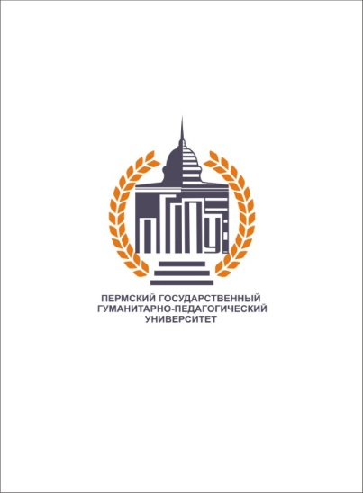

Federal state budget educational institution of higher education
«PERM STATE HUMANITARIAN PEDAGOGICAL UNIVERSITY» (PSHPU)
24 Sibirskaya St., 614990 Perm
Telephone (342) 215-18-49 (add 331),
Fax (342) 215-18-52 (add 332)
E-mail: postmaster@pspu.ru
http: www.pspu.ru
№_______ of__________

ACTING RECTOR K.B. EGOROV

